HSE Reading/Writing/Social Studies LESSON PLAN SET:
Technology in the Workplace
Lesson Plan One: How has Technology Changed the World and the Way We Live and Work?
based on “Technology in the Workplace” from CUNY Healthcare CareerKit. Unit I
Objectives:
- Students will understand how advances in technology affect the workplace
- Students will write a response to the article
- Students will build TASC test-taking skills by answering TASC-like questions about the article
- Students will build the following content knowledge for the TASC:
  - Law of supply and demand in the labor market
  - Effects of Industrialization
  - Global warming
  - Globalization
- Economic effects of globalization
- Students will develop presentation skills through a “teach-in” about the topics above
- Students will write a TASC essay based on their reading
Activity One: Thinking about Technology
- Tell students that they will be spending the next two sessions exploring technology in our work lives. They will begin by reading an article about this, but then they will go on to read several more articles that will help them build content knowledge they need for the TASC Social Studies test. They will also answer TASC-like reading questions and write a TASC essay.
- To begin, ask them to free-write on the following questions:
How has technology changed our lives?
How has it changed work?
What is good/bad about it?
- Explain that free-writing is just that—they should just get their ideas down on paper and not worry about grammar or spelling too much. These aren’t going to be collected. Walk around as students are writing and look over shoulders to get a sense of what they are thinking. When a student finishes, ask her to trade papers with another student who is finished. This way students will get a chance to read each other’s thoughts.
- Ask for students to report back briefly on what they wrote and whether they agreed with their partner. Write some notes on the board under each question.
- Give out the article. Tell students that good readers preview what they are going to read before they start reading. Ask students to look over the subtitles and make some predictions about what they are going to learn. Ask students whether they have questions of their own about this topic. If they do, write these on the board.
- Preview the following words: innovative, transaction, Linked In, Indeed.com, app developers, automation, big data, tech-savvy, proficient, peers. Find out what students know already, have students who do know explain what the words are as much as possible, and fill in as needed. Take brief notes on the board to help students understand the terms.
- Ask students to read silently. You may want to suggest that they stop after each subtitled section and write a few notes about what it was about.
- When students are finished, bring them together. Ask them what surprised them about the article, and whether they have worries based on what they have read. Was there information in the article that made them feel hopeful about their future working lives? What was it? Begin listing students’ worries on one side of the board and hopes on the other side.
- Tell students that the class is going to summarize the important information from sections 1, 2 and 3. Have each student choose a partner. Tell them that you want them to either (1) take notes or (2) underline the important information that a fellow student would need to know from each section.
- Model the process with numbered Section 1. Read out loud and say what you think a fellow student would need to know: “Ok I think the important thing is, don’t look for a job in a newspaper; look for a job on a website like Indeed.com, or social media like Linked in or Facebook.
- Have students work together in pairs to write a sentence that summarizes Section 2, then have them write their sentences on the board. Look at the sentences as a class. Discuss whether some are better than others and why.
- Repeat the process for Section 3. If possible, have students watch the 1-minute Jack Ma video, in which he talks about the things that humans can do better than machines. Review the term: innovative thinking. What does innovative mean?
- Optional: Have each student write a paragraph in which they react to one thing in the article that either interests them, disturbs them, or that they look forward to.
Activity Two: TASC Reading Practice
Materials: TASC Reading Questions
Steps:
- Tell students: that they have just done one of the most important things that reader do: they have summarized what they’ve read. When you create a summary in your mind, it allows you to remember what’s important. That’s an extremely important skill for the TASC reading test, but the TASC also emphasizes close reading—that is, paying very careful attention to the text—and understanding the way a text is organized, or structured. They have probably heard a teacher talk about organizing your ideas when writing an essay. All writers have to do this. Depending on what kind of information they are including, they will use a particular kind of organization. Give out the handout Types of Text Structure and let students read through it. Then ask students to look at Section 1—“The Way We Find Work.” What type of text structure do they see there? Is it a sequence of events? Is it comparing and contrasting two things? You may want to model how you use clues like “Long ago” and “Today” to clue you in that “Then” and “Now” are being compared.
- Give out the questions and have students work on them silently, then compare answers with a peer. Bring the class together and discuss students’ answers. This is a chance to talk about the types of questions students will encounter on the TASC: questions about words in context, text structure, main ideas and supporting details, claims and support.
- When the discussion is finished, ask students to turn to their partner and briefly discuss what they’ve learned about the TASC Reading test from doing these questions.
- Give out the TASC writing questions. Briefly review the rules for commas, colons and dashes, or ask students to find the rules in their notebooks. Have students do the questions, then review.
- HOMEWORK: Give out the packet of articles for Part Two of the lesson. Assign half of the class to read and answer the questions for Articles 1 and 2 (The Industrial Revolution and Climate Change). Assign half the class to read and answer questions for Articles 3 and 4 (What is Globalization and “Globalization Hurts Low-Skilled Workers Most)

HANDOUTS FOR LESSON PLAN ONE
THE TEXT:
Technology in the Workplace
Technology has affected the world of work since the rise of factories in 19th Century. For example, a machine called the cotton gin, that removes seeds from cotton after it is picked, made cotton manufacturing quicker and easier. When we talk about technology today, we usually mean hardware, such as hard drives and monitors; software, such as word processing programs; the internet; or networks, which allow computers to communicate with one another. Technology also refers to data collection, analysis and storage. It affects today’s labor market in many ways: the way we ﬁnd work, the types of jobs we do, the education and skills we need, the way we do work, and the way companies operate.
- The way we ﬁnd work

Long ago, people often looked for jobs in local newspapers, but today they use technology. Job search websites such as Monster, Indeed.com and Glass Door have become popular. People use social media sites like LinkedIn and Facebook to make themselves known, connect to others and ﬁnd opportunities. Employers use these sites too, to ﬁnd employees and research job applicants.

- The type of jobs we do

Advances in technology have made some jobs disappear and others appear. For example, because companies like Netﬂix can offer movies on the internet, there are fewer video rental stores. We used to see a travel agent, baggage collector, porter and ticket agent when we traveled by plane or train. There are fewer of those jobs now that we use websites to book our tickets, and electronic machines to get our tickets and to check our bags. Advances in technology create new jobs too, like ‘app developers’, social media specialists, and health information managers.

- The education and skills we need

A lot of work relies on technology. We use it to do simple tasks like answering phone calls. More and more employers rely on people to do more difﬁcult work that requires innovative thinking, ﬂexibility, creativity, and social skills. You need a person to plan the layout of products in a store so customers can ﬁnd them easily and you need a person to provide hands-on care for sick patients. You need technology, for cashiers to use during transactions and to store medical information of patients. In this technology driven labor market, individuals who want to get, keep and advance in a good job need to make sure that they have the education and skills that employers are looking for. This means knowing how to use technology and learning the skills that must be done by people.

- The way we do work

Technology has also changed the way we work, by:
- Making workers more productive – Using technology can help you do your job better. You can complete more tasks, do them faster and sometimes more accurately. For example, with programs like Word, you can create and edit a letter more quickly than if you were to do it by hand or on a typewriter.
- Reducing the tasks workers do themselves – Some tasks that workers used to do themselves are now done by technology. For example, lawyers can use computer programs to search through thousands of documents to ﬁnd certain information. This allows them to spend more time doing work computers can’t do, such as developing arguments for the courtroom.
- Replacing some workers – More and more, we rely on machines to do work without any help from humans. This is called automation. Many people wonder if machines or even robots will one day replace workers. Right now, machines can assemble car parts, answer customer calls and check passengers in at airports. Robots can work together to fulﬁll warehouse orders. Experts disagree on what kind of impact automation will have on work in the future.
- Making some workers more mobile – Mobile phones, computers and the internet have allowed employees to do work from almost anywhere at almost any time. For example, some ofﬁce workers can work from home for a local company or for a company based in another country. And, they can check email after the ofﬁcial end of the workday. Because of videoconferencing, we can even have meetings with people who are in different places around the world.
- Directly connecting people who need goods or services to people who can offer it – Businesses like Uber, Airbnb and Ebay allow sellers to connect with customers in moments. They offer transportation, accommodations and products to potential buyers through the internet.

- The way companies operate
With technology, organizations can produce goods and provide services more quickly, more accurately, on a larger scale and in new and improved ways. They can reach more customers. And, they can use huge amounts of information about individuals—known as ‘big data’—to help them sell more to customers. For many organizations, the way they use technology is what sets them apart from the rest.
Technology has changed the world of work in these ﬁve ways, but not all types of technology have the same impact. Some technologies totally transform the way people and organizations work. The internet is a good example; it changed everything. Other technologies that may transform our lives include driverless cars and advanced robots that can work alongside or replace employees altogether. And, some jobs seem to be affected by technology more than others. For example, jobs that involve activities such as data entry, assembly line work or routine design work have all become reliant on technology.
Technology has had many positive effects, but it has also had some negative. For example, the internet has allowed a wide range of individuals to access an incredible amount of information quickly, but it has made security and privacy an important issue. Hackers now can get conﬁdential information that they were not intended to have. Governments are catching up to these changes by making new laws and regulations to keep people more safe.
Jobseekers and employees in today’s labor market must make sure they are tech-savvy. This can include:
• knowing how to operate a computerized cash register
• being proﬁcient in Microsoft Ofﬁce including Word and Excel programs
• operating medical technology that can require ongoing training as the technology evolves
Employees can raise their awareness by staying current with technological trends in their ﬁeld, by reading online or print materials about their industry. Jobseekers can prepare for interviews doing job research and getting training. Jobseekers who are not tech-savvy may be at a disadvantage compared to their more tech savvy peers.
TASC Reading Questions for “Technology in the Workplace”
- Which of the following is the BEST summary of the article:
- Technology has replaced some human workers but not others
- Over the centuries, work has changed due to technology
- There are positive and negative effects of technology in the workplace
- Technology has impacted the way people look for work, the work people do, and worker productivity
- Which detail from the text best supports the idea that technology has changed the way companies operate?
A. The internet is an example; it changed everything.
B. Some jobs seem to be more affected by tech than others.
C. For example, jobs that involve data entry, assembly line work or routine design work have all become reliant on technology.
- Which BEST describes the text structure of Section Two?
- Description
- Compare/contrast
- Problem/solution
- Technology…affects today’s labor market in many ways: the way we find work, the types of jobs we do, the education and skills we need, the way we do work, and the way companies operate.
The purpose of these two sentences is to…
- Provide details about technology in the workplace.
- Summarize the first section of the article.
- Provide a preview of the main types of information that will be included
- Support the author’s claim that all workers need to develop technical skills.…
- .Which dictionary definition applies in this sentence from the article: Advances in technology create new jobs too, like ‘app developers,’ social media specialists, and health information managers.
Dictionary definitions for “Advance”:
Advance noun:1. Something done before an expected event. . 2. A change, discovery or invention that brings progress. 3. forward movement or progress along a road or over a particular distance.
- 1
- 2
- 3
- All of the above

- Which dictionary definition applies in this sentence from the article: Robots can work together to fulfill warehouse orders.
Dictionary definitions for “Fulfill”:
Fulfill verb:1. To achieve a goal, wish or aim . 2. To do something that is useful or necessary. 3. To do something because it is required by a rule. 4. To package and send an order that has been made by a customer.
A.1
B.2
C. 3
D. All of the above

Types of Text Structure
Sequence | Sequencing things is putting them in order. Often, sequence is thought of as time order, the order in which things occur. This structure is suited to writing stories of any kind. For example, sequence structure is used in books about history, which tell the story of past events. It is also frequently used in short stories and novels, which usually tell stories about fictional events. Time order is also used to describe processes, so you will find it in instruction manuals, recipes and directions.  Another type of sequence is order of importance. Order of importance is often used in text that seek to persuade the reader, such as an argument or a speech. In a persuasive text, the writer might start with the least important point and end with the most important point. This text structure helps persuade the reader by building to a strong conclusion.
Compare  /Contrast | Many different types of texts use this structure. A novel might contrast two people, a presentation might compare two business plans, or an informative text might compare and contrast two paintings. The comparison can be made point by point or subject by subject.
Cause/  Effect | Cause-and-effect structure is common in history texts. It is also frequently found in investigative articles, biographies, autobiographies, and other texts that analyze events. This structure can focus on multiple causes of one event, on multiple effects that one event causes, or on a chain of related events, in which each event causes another. In the workplace, reports frequently use cause and effect structure to analyze marketing, financial, and other company issues.
Description | Description can be general or detailed. It includes sensory details of what is seen, touched or heard. It gives details on distance and space between things and appearances. It is common in fiction, but also in news reports, travel writing and many other texts.
Problem/  Solution | This text structure may focus on how one solution can solve one or more problems, or on how one problem can be addressed by one or more solutions. It is perhaps most familiar from user manuals, which often contain a troubleshooting guide. Other texts where problems and solution structure is common are recommendation reports and advertising.

TASC Writing Questions for “Technology in the Workplace”
- It affects today’s labor market in many ways: the way we find work, the types of jobs we do, the education and skills we need, the way we do work, and the way companies operate.
What change should be made to the punctuation in the sentence above?
- Add a comma after “market,”
- Remove the comma before “and”
- Remove the colon after ‘ways”
- No change is needed.

- The internet is a good example; it changed everything.
What is the best revision to the sentence above?
- Put a period after example, and start a new sentence with “It.”
- Replace the semi-colon after “example” with a comma.
- Replace the semi-colon after “example with a colon.
- No change is needed.

- And, they can use huge amounts of information about individuals—known as ‘big data’--to help them sell more to customers.
Which revision should be made to the punctuation in the sentence above?
- Place commas where the dashes are.
- Remove the comma after “And.”
- Place a comma after “information”
- No change is needed.

HSE Reading/Writing/Social Studies LESSON PLAN SET:
Technology in the Workplace
LESSON PLAN TWO
Building Content Knowledge on Industrialization and Globalization for the Social Studies TASC Test
Activity One: Introducing the concepts
- Tell students that they will continue exploring content from the session before. Today, they will be doing a few things simultaneously: understanding more about the world economy and historical trends; building content knowledge for the Social Studies TASC, practicing reading and writing skills, practicing presentation skills.
- Ask students to begin with a free write. The prompt: Make a list of all the machines you use in your life. Write a paragraph about how your life would be different without machines. Allow students 5-10 minutes to write, then bring the class together and discuss the second question: how would life be different without machines? Be sure to talk about how people would have gotten clothing before machines. How would people have gotten food? What would daily life be like?
- Write these words on the board: Industrial Revolution, Climate Change/Global Warming, Globalization. Ask students to come to the board in groups or pairs and write down anything they know about any of the terms.
- Briefly talk through the terms, drawing on student notes to do so. Ask students what a “revolution” is and what “industrial” means. Discuss what “globalization” might mean.
- Give students some basic information about the Industrial Revolution: it took place in England. It began in about the 19th century. Review the information that people would have made clothes at home in hand looms before there were machines and factories.
Activity Two: Using Graphs to Build Background Knowledge
- Introduce the first graph: Home and Factory Weaving in England. Ask students to just look at the graph for a few minutes. Write “Notice” and “Wonder” on the board. Ask students to write down what they notice and what they wonder--any questions they have. Ask for a report back, and as students report back, write their statements and questions on the board. Hopefully, some of the following features will come out of this process: What do the black men stand for? What do the orange men stand for? How can they find out? What do the blue boxes stand for? What do the numbers stand for?
- If no student volunteers the information, explain that the numbers are dates, and ask students to look at the dates. Tell them that a lot of graphs show change. What things have changed in this graph? Write a statement on the board with student input, and using a sentence starter, for instance: Between -------------- and -------------------, there was a change in _______________________. For instance, ___________________________________________. Ask students to write additional sentences about changes they see in the graph.
- You may want to begin a timeline on the board, starting at 1820 and with an indicator at 1880. Ask students to write true statements about what they see on the pictograph for 1820 and what they see for 1880. Write the statements students suggest for each date, or have them come up to the board and write their sentences, then ask the rest of the class if the statements are accurate or not, and how they know. This encourages students to rely on their own understandings and focus on the “how” rather than right answers.
- Optional: You may also want to talk with students about how the pictograph could be converted to a line graph. With student help, create a line graph with two axes. Write years on the bottom. Have students help you write the scale that should appear on the x axis. Ask students, on this graph, what should go along the x axis, if I am putting years along the y axis? Talk about how the line graph shows change over time.
- Ask students to look at Graph 2, “Farm Jobs, % of Total U.S. Jobs 1790-2000. Again, ask students to just “Notice” and “Wonder” for the first five minutes, then report back as you write their statements and questions on the board. As the discussion unfolds, some of the following will probably come up: What do the numbers on the bottom mean? The numbers on the side? What is the span of time shown? What change is shown? You may want to write a sentence starter on the board: The graph shows a change that took place between ___________ and _________________________. The change is ___________________________.
- Alternatively, you may want to model writing a true statement about the graph on the board, for instance, “Between 1790 and 2000, farm jobs went from 90% of all jobs to 2.6% of all jobs.” Ask students to work on their own statements and have them come up to the board and write them. Ask the rest of the class to say whether they are true and accurate, and how they know.
- Have students help you extend the timeline you wrote on the board to reflect the new information from this graph, then ask students: What do you think is the relationship between this graph and the one we looked at before? Discuss the fact that more people were going to work in factories.
- Ask students to complete the sentence: One way I made sense of this graph was….One thing that surprised me about this graph was…One thing that confuses me about this graph is…..
Activity Three: Reading “The Industrial Revolution Changed Everything”
- Tell students that now they will read an article about the Industrial Revolution. Give out the article. Tell students that good readers preview the text—ask students to look over the article and see what they notice in the pictures and the subheadings. What are some things they will learn from this article?
- Tell students that good readers often have questions in their mind as they read. Lead students in turning the subheadings into questions that they should be able to answer in a few words after they read.
- Have students read the article silently.
- When students have finished, ask them about the title of the article “The Industrial Revolution Changed Everything.” Without looking back at their papers, what can they remember about what some of the things that changed?
- Tell students that later in the class they will be summarizing other, related articles and presenting what they have learned. This time, we will practice together as a class. What they need to do is boil down the information in the article to the most important points.
- Return to the questions students created out of their subtitles. Use these to create a graphic organizer on the board. Ask the students to copy the graphic organizer into their notebooks.
- Discuss the importance of paraphrasing. If you can put information into your own words, you have really understood what’s important. Model for students how you would fill in the graphic organizer by sections by reading each section aloud then “talking” the notes that you would write in the graphic organizer. You might want to start by saying what information you would underline and why it is important, then put it into your own words An example is below.
- After modeling the first two sections, divide the class in half, then subdivide into pairs. Have each half of the class write a few sentences that paraphrase either the section called “The Spread of the Industrial Revolution” or “The Consequences of the Industrial Revolution.”
- Choose a pair that has written a strong paraphrase to come and write theirs in the graphic organizer on the board. Ask the rest of the class that worked on that section to give feedback on whether the important information is there, if anything is left out, and whether the writers used their own words.
How did the Industrial Revolution transform everything? | People used to provide their own energy by eating plants and animals and burning wood, but the Industrial Revolution changed all that
Why were steam engines important? | In England, people had cut down all the trees, so they started to use coal, but it was hard to get the coal using horses. Watt invented the steam engine, then they used steam engines to make textile factories. From the steam engines they could make steam trains and steamships and a lot of other machines. People moved to cities to work in factories. There were factories and bigger, more crowded cities.
How did the Industrial Revolution spread and what were the effects?
What were the consequences of the Industrial Revolution?

Activity Four: Reading to Prepare Presentations
- Divide the class into thirds. Further subdivide each group into pairs. One group will work on “Climate and Climate Change.” One group will work on “Globalization,” and one group will work on “Globalization Hurts Low-skill Workers Most.” Review the steps that you want students to take in preparing their presentations:
- Preview and make subtitles into questions
- Read silently
- Create a graphic organizer using the questions
- When the group is finished reading, each pair of students will summarize/paraphrase one section-choose one partner and decide which pair of students will summarize which section of the article.
- Reread your section and underline, then work with your partner to identify what’s important and to paraphrase it and write it in the graphic organizer.
- When the graphic organizer is finished, you will have a guide as you talk about your section.
- As a group, meet and discuss: what is important for people to know from your section? What main points will you make? How will you introduce the topic? What visual will you use to spark the attention of your audience and how is it related to what you have to say? Is all your information paraphrased?
- Circulate as students are working in their groups to provide support.
Activity Five: Class Presentations
- Tell students that each group will present for 3-5 minutes. Brainstorm with students what makes a good presentation: a good visual to start off, eye contact, clear speaking, organized information.
- You may want to briefly report on the Industrial Revolution article to model, then ask them for feedback—what could you have done better?
- Give students an additional 3-4 minutes to “rehearse” in their groups, then begin the presentations, with 5 minutes allotted to each group. Encourage the rest of the class to ask questions.
- If you feel that students are comfortable, ask the “audience” to tell the presenters one thing they really liked about the presentation and one thing that they thought could be improved or didn’t understand.
Homework: 1. For the article you presented on, do the multiple choice questions. Study the key words for a quiz.
LINKS TO GRAPHS BELOW:
Home vs. Factory Weaving in England during the Industrial Revolution
file://filer1/users$/kabbh/Industrialization%20in%20England%201820-1880.pdf
U.S. Becomes World Manufacturing Powerhouse
http://images.slideplayer.com/33/8261309/slides/slide_4.jpg
Farm jobs as % of U.S. Jobs
http://4.bp.blogspot.com/_otfwl2zc6Qc/S7v_t-YLdiI/AAAAAAAANL4/mvqKtxmrbg8/s1600/farmjobs.jpg
Keeling’s Graph Global Temperatures
https://robertscribbler.files.wordpress.com/2014/01/global-temperatures-since-1880.gif

Impact of Global Warming
https://themadisonian.net/wp-content/uploads/2017/01/10-other-climate-effects-EPA-planetsave.png
Mcdonalds: The Fries that Bind Us
http://www.altenergyshift.com/uploads/gallery/album_9/gallery_1_9_304015.jpg
Smurfs Chinese Factory
https://www.theepochtimes.com/assets/uploads/2017/11/30/GettyImages-460140196-700x420.jpg
Average Hourly compensation costs of manufacturing employees, selected Economies and Regions, 2002-2009
https://www.bls.gov/ILC/chinachart2.png
Cartoon on Globalization
https://www.bing.com/images/search?view=detailV2&ccid=1dDKGOCw&id=6F428C3CEA6E0FE027C22950CA580146204E03D1&thid=OIP.1dDKGOCwB9awy6T2jAtyuwHaFX&mediaurl=http%3a%2f%2fiblog.dearbornschools.org%2ffarhoud%2fwp-content%2fuploads%2fsites%2f151%2f2015%2f01%2fglobalization-and-free-trade.jpg&exph=1016&expw=1400&q=Global+Trade+political+cartoons&simid=608014848357371196&selectedIndex=6&ajaxhist=0

Texts for Activity Five:

The Industrial Revolution Changed Everything
The transformation of the world
Try to imagine your life without any machines working for you. Make a list of the machines in your house. You may be surprised how many there are.
Imagine people who grew up before machines. How did they move from place to place? How did they communicate? What foods did they eat?
At one time, humans provided most of their own energy. They ate plants and animals for fuel, burned wood, and used farm animals like cows, sheep and horses to eat and to do work like plowing fields. Windmills and waterwheels captured some extra energy, but little could be saved. All life depended on the energy the Sun sent to the Earth.
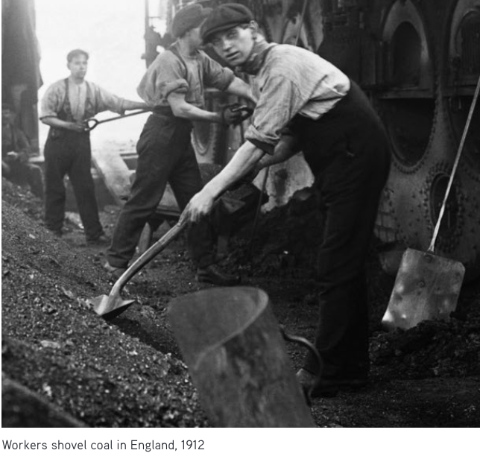
Everything changed during the Industrial Revolution, which began around 1750.

Early steam engines
The story of the Industrial Revolution begins on the small island of Great Britain. By the early eighteenth century, people there had cut down most of their trees to build houses or ships and for cooking and heating. They needed something else to burn. They turned to the hunks of black stone (coal) that they found near the surface of the Earth. Soon they were digging deeper to mine it. These coal mines, deep in the Earth, began to fill with water. Using horses to pull up bucketfuls of water was too slow.
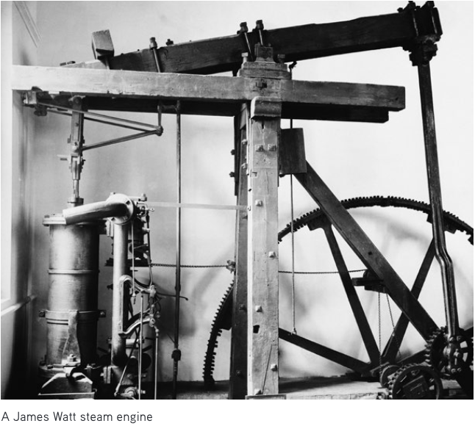
To the rescue came James Watt (1736–1819), a Scottish instrument-maker. In 1776, he designed an engine that used burning coal to produce steam. The steam drove a piston. This steam engine was first used to efficiently pump water out of coal mines. But his engine worked well, and it was put to other uses. He became a wealthy man. After his patent ran out in 1800, others improved on his engine. By 1900, engines burned 10 times more efficiently than they had a hundred years before.
At the beginning of the nineteenth century, British colonies in North America were producing lots of cotton. The cotton was shipped from North America to Britain, where it was made into clothing in factories. Machines were used to spin the cotton thread on spindles and to weave it into cloth on looms. Attaching a steam engine to these machines made the work go much, much faster. One steam engine could power many spindles and looms. This meant that people had to leave their homes and work together in factories.
Early in the nineteenth century, the British also invented steam locomotives and steamships, which revolutionized travel. In 1851, they held the first world’s fair. They exhibited telegraphs, sewing machines, revolvers, reaping machines, and steam hammers to demonstrate that they were the world’s leading manufacturer of machinery. By this time, the characteristics of industrial society — smoke rising from factories, bigger cities and denser populations, railroads — could be seen in many places in Britain.
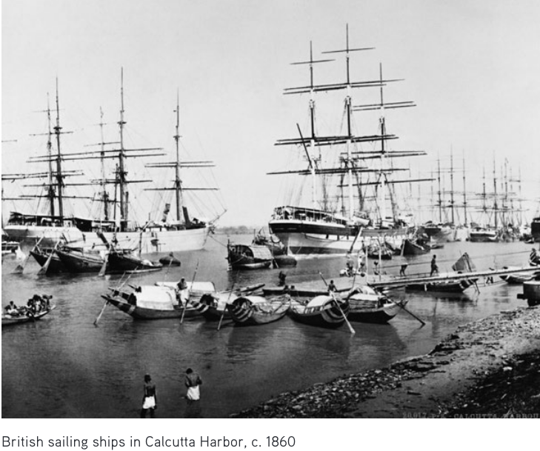

The spread of the Industrial Revolution
Britain wanted to keep secret how its machines were made. But visitors soon learned about them and took the techniques back home. Sometimes they smuggled machines out in rowboats.
The first countries after Britain to develop factories and railroads were Belgium, Switzerland, France, and the states that became Germany. Building a national railroad system was an essential part of industrialization. Belgium began its railroads in 1834, France in 1842, Switzerland in 1847, and Germany in the 1850s.
Industrialization came to the United States in 1789. Samuel Slater left Britain for Rhode Island, where he set up the first textile factory on U.S. soil. He couldn't bring any notes or plans from Britain, so he had to set up the factory from memory.
Railroad construction in America boomed from the 1830s to 1870s. The American Civil War (1861–1865) was the first truly industrial war. The increasingly urbanized and factory-based North was fighting against the agriculture-based South. Industrialization grew explosively after the war. By 1900, the United States had overtaken Britain in manufacturing, producing 24 percent of the world’s output.
Industrialized nations used their strong armies and navies to colonize many parts of the world that were not industrialized. They needed raw materials for their factories. This colonization is known as imperialism. In 1800, Europeans occupied or controlled about 34 percent of the land surface of the world. By 1914, this had risen to 84 percent.

Consequences of the Industrial Revolution
The effects of industrialization are staggering. In 1700, before fossil fuels were in use, the world’s population was 670 million. By 2011, it was 6.7 billion, a tenfold increase in only 300 years.
In the twentieth century alone, the world’s economy grew fourteenfold, per-capita income grew almost fourfold, and the use of energy expanded at least thirteenfold. This kind of growth has never before occurred in human history.
Many people around the world today enjoy the benefits of industrialization. With extra energy flowing through the system, many of us do much less physical labor than earlier generations. People today are able to feed more babies and bring them to adulthood. Many people vote and participate in modern states. These states provide education, social security, and health benefits. Large numbers of people enjoy levels of wealth, health, education, travel, and life expectancy unimagined before industrialization.
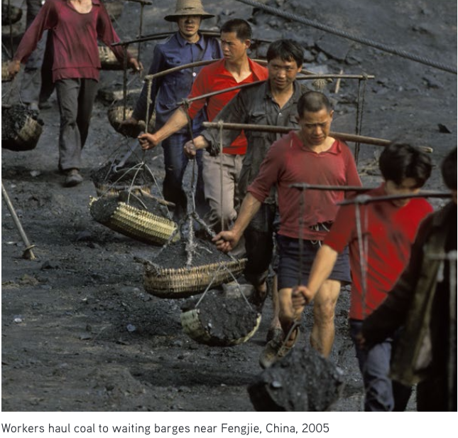
The benefits of industrialization, however, have come at great cost. For one thing, the rate of change (acceleration) is now so rapid that individuals and social systems struggle to keep up. And it can be argued that life has become depersonalized in the era of mass production.
As the industrial system has become more complex, it has also become more fragile. Industrialization needs many components to work together smoothly. Any one component could fail.
We know that many of the essential components of the industrial system, and the natural resources it depends on, are being undermined. The soil, the oceans, the atmosphere, the underground water levels, plants, and animals are all at risk.
Will uncontrolled growth continue, or are we approaching the end of an unsustainable industrial era? Whatever the future holds, we’ll be debating — and dealing with — the consequences of modernization for years to come.
Which section of the article BEST explains how various nations changed during the Industrial Revolution?
- "Early steam engines"
- "Why Britain?"
- "The spread of the Industrial Revolution"
- "Consequences of the Industrial Revolution"
Read the following paragraph from the section "The spread of the Industrial Revolution".
Industrialized nations used their strong armies and navies to colonize many parts of the world that were not industrialized. They needed raw materials for their factories. This colonization is known as imperialism. In 1800, Europeans occupied or controlled about 34 percent of the land surface of the world. By 1914, this had risen to 84 percent.
Which of the following BEST explains the purpose of this paragraph?
- It emphasizes how important the Industrial Revolution was for everyone.
- It indicates that every nation was affected by the Industrial Revolution.
- It shows how the Industrial Revolution had an impact on nations that were not a part of industrialization.
- It demonstrates that the Industrial Revolution created new opportunities for nations that were not industrialized.
Why did the author MOST LIKELY choose to end with the following paragraph?
Will uncontrolled growth continue, or are we approaching the end of an unsustainable industrial era? Whatever the future holds, we’ll be debating — and dealing with — the consequences of modernization for years to come.
- to predict the future effects of the Industrial Revolution and give a call to action
- to illustrate the overwhelmingly negative impacts of the Industrial Revolution
- to show that the effects of the Industrial Revolution are largely positive
- to indicate that the effects of the Industrial Revolution are not fully known, but will affect everyone

CLIMATE AND CLIMATE CHANGE
The climate of a region or city is its typical or average weather. For example, the climate of Hawaii is sunny and warm. But the climate of Antarctica is freezing cold. Earth's climate is the average of all the world's regional climates.
Climate change, therefore, is a change in the typical or average weather of a region or city. This could be a change in a region's average annual rainfall, for example. Or it could be a change in a city's average temperature for a given month or season.
Climate change is also a change in Earth's overall climate. This could be a change in Earth's average temperature, for example. Or it could be a change in Earth's typical precipitation patterns.

What Is The Difference Between Weather And Climate?
Weather is the short-term changes we see in temperature, clouds, precipitation, humidity and wind in a region or a city. Weather can vary greatly from one day to the next, or even within the same day. In the morning the weather may be cloudy and cool. But by afternoon it may be sunny and warm.
The climate of a region or city is its weather averaged over many years. This is usually different for different seasons. For example, a region or city may tend to be warm and humid during summer. But it may tend to be cold and snowy during winter.
The climate of a city, region or the entire planet changes very slowly. These changes take place on the scale of tens, hundreds and thousands of years.

Is Earth's Climate Changing?
Earth's climate is always changing. In the past, Earth's climate has gone through warmer and cooler periods, each lasting thousands of years.
Observations show that Earth's climate has been warming. Its average temperature has risen a little more than 1 degree Fahrenheit during the past 100 years or so. This amount may not seem like much. But small changes in Earth's average temperature can lead to big impacts.

What Is Causing Earth's Climate To Change?
Some causes of climate change are natural. These include changes in Earth's orbit and in the amount of energy coming from the sun. Ocean changes and volcanic eruptions are also natural causes of climate change.
But most scientists now agree that human activity that began at the time of the Industrial Revolution has been the main cause of global warming.
At the time of the Industrial Revolution, people found an extra source of energy that could work for them. That source was fossil fuels — coal, oil, and natural gas. A fossil is a remnant of an ancient animal or plant that becomes embedded in rock instead of rotting. Fossil fuels are made up of the remains of plants and animals from much earlier geologic times. When they were burned, they released energy, originally from the Sun and converted to carbon dioxide, then stored for hundreds of millions of years under the ground.
Coal was formed when huge trees from the Carboniferous period (345 million to 280 million years ago) fell and were covered with water, so that oxygen and bacteria could not decay them. Materials pushing down compressed them into dark, carbonic, burnable rock.
Most of the Earth’s oil and gas formed over a hundred million years ago from tiny animal skeletons and plant matter that fell to the bottom of seas or were buried in sediment. This organic matter was compressed by the weight of water and soil.
Coal, oil, and gas are relatively common on Earth. But they are not evenly distributed. Some places have much more than others due to the diverse ecosystems that existed long ago.
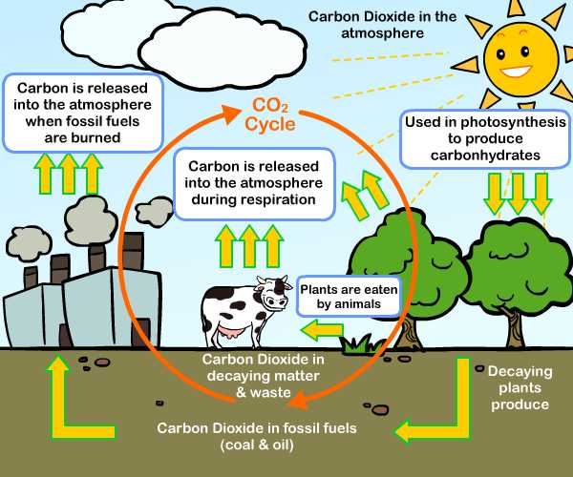
Most scientists think that recent warming can't be explained by nature alone. Most scientists say it's very likely that most of the warming since the mid-1900s is due to the burning of coal, oil and gas. Burning these fuels is how we produce most of the energy that we use every day. This burning adds heat-trapping gases, such as carbon dioxide, into the air. These gases are called greenhouse gases.
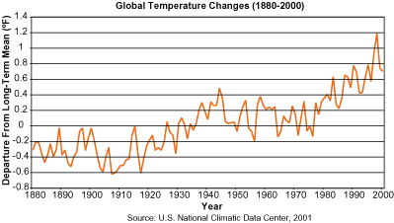

Look at the graph above. What do you notice about changes in mean temperature between the years 1880 and 2000?

What Is The Forecast For Earth's Climate?
Scientists use climate models to predict how Earth's climate will change. Climate models are computer programs with mathematical equations. They are programmed to mimic past climate as accurately as possible. This gives scientists some confidence in a climate model's ability to predict the future.
Climate models predict that Earth's average temperature will keep rising over the next 100 years or so. There may be a year or years where Earth's average temperature is steady or even falls. But the overall trend is expected to be up.
Earth's average temperature is expected to rise even if the amount of greenhouse gases in the atmosphere decreases. But the rise would be less than if greenhouse gas amounts remain the same or increase.

What Is The Impact Of Earth's Warming Climate?
Some impacts already are occurring. For example, sea levels are rising and snow and ice cover is decreasing. Rainfall patterns and growing seasons are changing.
Further sea-level rise and melting of snow and ice are likely as Earth warms. The warming climate likely will cause more floods, droughts and heat waves. The heat waves may get hotter and hurricanes may get stronger.

What Is The Difference Between "Climate Change" And "Global Warming"?
"Global warming" refers to the long-term increase in Earth's average temperature.
"Climate change" refers to any long-term change in Earth's climate or in the climate of a region or city. This includes warming, cooling and changes besides temperature.

How Does NASA Study Climate Change?
Some NASA satellites and instruments observe Earth's land, air, water and ice. Others monitor the sun and the amount of energy coming from it. Together, these observations are important for knowing the past and present state of Earth's climate. They are important for understanding how Earth's climate works. And they are important for predicting future climate change.

What Is Being Done About Climate Change?
The United States and other countries are taking steps to limit or reduce greenhouse gases in the atmosphere. These steps include using energy more efficiently and using more clean energy. Clean energy is energy that puts less or no greenhouse gases into the atmosphere. The sun, wind and water are sources of clean energy.
Many nations, states and communities are planning for climate change impacts that may be unavoidable. For example, some coastal areas are planning for flooding and land loss that may result from rising sea levels.

What Can You Do to Help?
You can help by using less energy and water. For example, turn off lights and TVs when you leave a room. And turn off the water when brushing your teeth. You can help by planting trees, which absorb carbon dioxide from the atmosphere.
Another way to help is by learning about Earth and its climate. The more you know about how Earth's climate works, the more you'll be able to help solve problems related to climate change.
Complete the following sentence.
The author mainly explains the importance of our current climate change by:
- explaining that the climate is always changing.
- describing the difference between climate change and global warming.
- showing how the average temperature has only risen 1 degree.
- describing effects like ice melting, seasonal changes and stronger storms.
According to the article, each of the following has contributed to climate change EXCEPT:
- stronger hurricanes
- fossil fuel burning
- changes in Earth's orbit
- increased levels of carbon dioxide
Read the following sentence from the section "Is Earth's Climate Changing?"
But small changes in Earth's average temperature can lead to big impacts.
Which of the following versions of the sentence creates a more alarming tone by replacing the word "big" in the sentence?
- But small changes in Earth's average temperature can lead to OBVIOUS impacts.
- But small changes in Earth's average temperature can lead to NOTABLE impacts.
- But small changes in Earth's average temperature can lead to STAGGERING impacts.
What is the BEST way to describe the tone in the last paragraph of the article? What evidence leads you to this answer?
- alarming: the more you know
- hopeful: you'll be able to help solve problems
- demanding: another way to help is by learning about Earth
- sympathetic: the more you'll be able to help

WHAT IS GLOBALIZATION?
Globalization means connecting different parts of the world. This leads to more international cultural, economic and political activities. As people, ideas, knowledge and goods move around the globe, the experiences of people around the world become more similar.
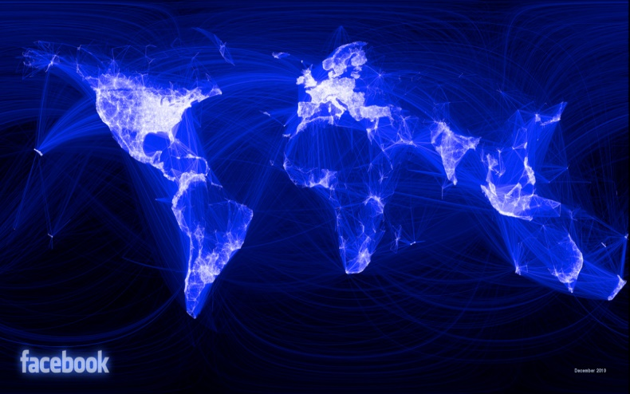A map shows connections across the world on the social media site, Facebook. The spread of the Internet and the increase of the number of people with access to technologies like smartphones are key components of globalization. Map: Paul Butler via Flickr.

Communication
Modern communication has played a large role in cultural globalization. Today, news and information zip instantly around the world on the Internet. People can read information about foreign countries as easily as they read about their local news.
About 60 percent of the people in the world now use cellphones. A farmer in Nigeria can easily talk to his cousin who moved to New York City, New York. The success of global news networks like CNN has also helped globalization. People all over the world can see the same news 24 hours a day.

Travel
Globalization means connecting different parts of the world. This leads to more international cultural, economic and political activities. As people, ideas, knowledge and goods move around the globe, the experiences of people around the world become more similar.
People are traveling farther and more often because of globalization. International travel has also helped globalization. Each year, millions of people move from one country to another in search of work. Sometimes, these migrant workers travel a short distance, like between Mexico and the United States. Sometimes, they travel many thousands of miles to find better-paying jobs.
People do not travel just for work, of course, but also for tourism. Globalization has influenced trade, taste and culture by exposing travelers to new ideas about food, goods and politics.

Popular Culture
Popular culture has also become more globalized. People in the United States enjoy listening to South African music and reading Japanese comic books. American soap operas are popular in Israel.
Clothing styles have also become more uniform as a result of globalization. National and regional costumes have become rarer as globalization has increased.
There has also been an exchange of foods across the globe. People in England eat Indian curry, while people in Peru enjoy Japanese sushi. Meanwhile, American fast-food chains have become common throughout the world. McDonald's has become a symbol of globalization. It has more than 31,000 restaurants in 118 countries. And people all across the world are eating more meat and sugary foods, like those sold in fast-food restaurants.

Economy
The international economy has also become more globalized. International trade is very important to the economies of most countries around the world. American software companies, like Microsoft, Apple and Google, make a great deal of money from buyers around the world. The economy of the country of Saudi Arabia almost completely depends on selling oil.
To increase trade, many countries have made free-trade agreements with other countries. Under free-trade agreements, countries agree to remove trade barriers. For example, they may stop charging taxes, or money, when people sell goods to other countries.
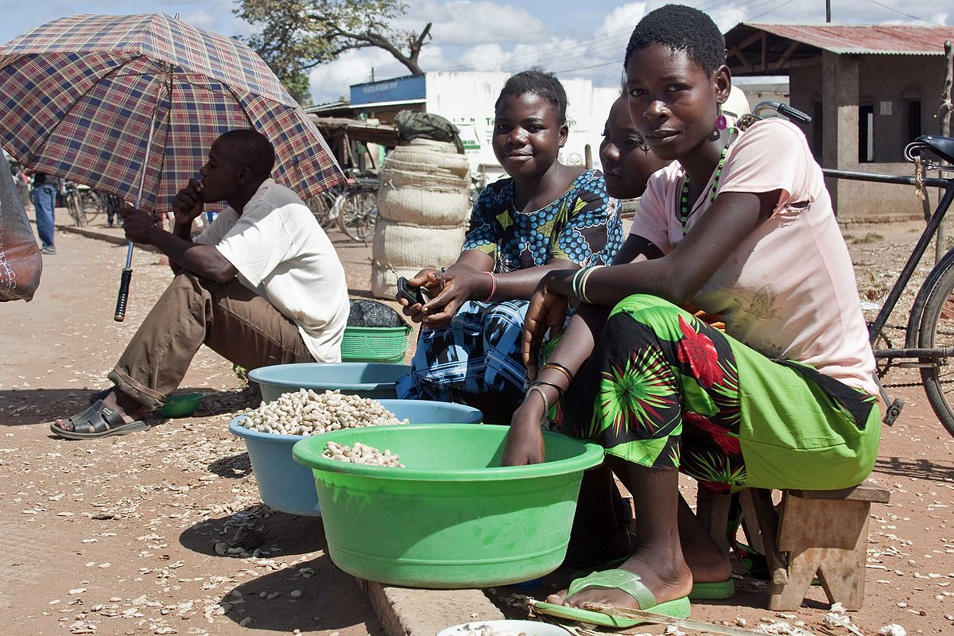Women sell ground nuts in Malawi, Africa. In less developed countries, people tend to earn lower wages and there are fewer laws protecting workers. Still, even in some of the most impoverished places in the world, more people have access to technologies like cell phones and the Internet than ever before. Photo: Swathi Sridharan/Flickr. [click to expand]
Economic globalization has allowed many corporations based in the West to move factories and jobs to poorer countries. This process is called outsourcing. The corporation can pay lower wages because poorer countries do not have as many services. In these countries, there might also be fewer laws protecting the environment and workers' safety. This also lowers costs for the corporation and often allows them to sell cheaper goods..
Economic markets have become global. This means that people and organizations put their money in companies and banks all over the globe. Because of this, if a big bank or corporation does poorly, it will have consequences globally. This is what happened with the financial crisis that began in the United States in 2006 and quickly spread around the world.

Politics
Countries have also become more connected politically. Many problems facing the world today cross national borders. Countries must work together to solve them. For example, efforts to fight crime and deal with global climate change involve many different countries. Climate change is the heating of the planet due to gases from cars and factories.
Globalization has also had other good consequences. For example, it has made advanced medicines more easily and widely available. Jobs available through globalization have lifted many people out of poverty.
However, not everyone says that globalization is good. Some people worry that American culture will destroy local cultures around the world. They fear that everyone will end up eating hamburgers and watching Hollywood movies.
People also blame free trade for unfair working conditions. They say that outsourcing has caused wealthy countries to lose too many jobs. But supporters of globalization say that factory workers in poor countries are making much better wages. They argue that free trade has lowered prices in wealthier countries and has improved the economy of poorer countries. They say globalization is a win for everyone, in the long run.
Read the paragraph from the section "Popular Culture."
Clothing styles have also become more uniform as a result of globalization. National and regional costumes have become rarer as globalization has increased.
Which of the following words, if it replaced the word "uniform" in the paragraph above, would CHANGE its meaning?
- diverse
- similar
- alike
- consistent
Read the paragraph from the section "Economy."
Economic markets have become global. This means that people and organizations put their money in companies and banks all over the globe. Because of this, if a big bank or corporation does poorly, it will have consequences globally. This is what happened with the financial crisis that began in the United States in 2006 and quickly spread around the world.
Why does the author mention the financial crisis?
- to describe the economy created by globalization
- to explain a negative consequence of globalization
- to highlight the difference between the economies of rich and poor countries
- to present the reasons for the United States' economic failure
Read the section "Politics."
What does this section explain that other sections do not?
- why some companies move jobs to poor countries
- how countries are working together to solve problems
- why people around the world eat at McDonald's
- how globalization can help people in poor countries
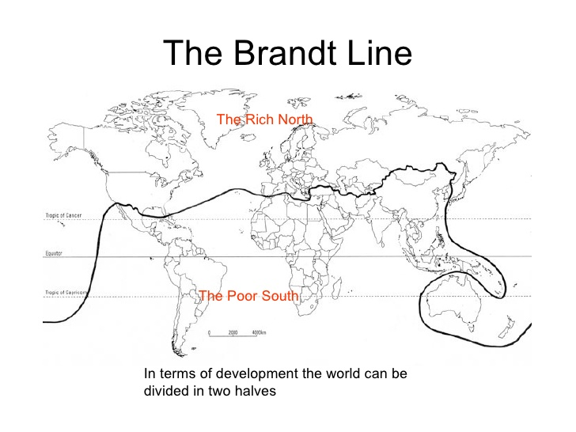
GLOBALIZATION HURTS LOW-SKILL WORKERS MOST
The Conversation, adapted by Newsela staff
Word Count 853
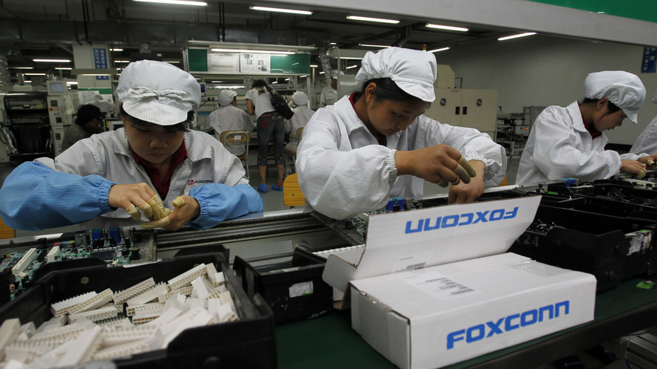The world is more connected than ever. Countries thousands of miles apart depend on one another for goods and services. This is all part of a process called globalization.
A number of positive changes have been brought about by globalization. Around the world, more people are connected to the internet. It is easy to communicate and share information across long distances. Money can be easily transferred electronically.

Manufacturing Jobs Now Harder To Find
For some, however, globalization has not necessarily been a force for good. It has changed the kinds of jobs that are available. In some countries, factory work is booming. In others, manufacturing jobs are getting harder to find.
Globalization is causing a major debate among politicians and experts everywhere.
In American politics, there are frequent calls to decrease trade with other countries.
Over the past 25 years, a dramatic change has occurred in manufacturing. Manufacturing is the production of goods like cars or clothing, by people working in factories.

China Now Leading The Manufacturing Race
In the early 1990s, 30 percent of all manufacturing took place in the United States. For nearly 100 years, the United States had been the world's leading industrial producer. At that time China produced only 5 percent of goods made in factories.
Today that position has completely reversed. China produces 25 percent of manufactured goods. The U.S. produces only 15 percent.
It’s easy to see why factory workers are so concerned.
Differences in labor costs between the U.S. and China explain much of this change. Manufacturing jobs can be done by many different people. These workers are referred to collectively as low-skill labor because factory jobs usually do not require a college degree.

Cheap Labor In "Developing" Countries
The production of goods such as clothing and footwear, motor vehicles, and electronic consumer goods depends on low-skill labor.
In poorer, "developing" countries, wages paid to low-skill workers are much lower than in richer, developed countries. In turn, developing countries are able to produce these manufactured goods more cheaply.
Developing countries such as China have been increasing their international trade. This has caused a massive switch: most manufactured goods are now made in developing, rather than developed, countries.

Low-Skilled Workers In The U.S. Worse Off
Recent research shows that low-skilled workers in the U.S. are now much worse off because of this change.
Workers affected by cheap labor in China are seeing their income decline. Some are not able to find jobs. This negative effect on annual earnings has been largest for workers with the lowest earnings.
It's important to note that certain locations in the United States are affected more than others by this manufacturing shift. A large portion of low-skill factory workers in the United States are concentrated in the Midwestern and Southeastern regions.
This also explains why it is taking workers so long to get back into work. More people are chasing the same available jobs in these regions. They are all competing with each other for the same few jobs, which means they spend longer average times without work.

More Jobs For High-Skilled Workers
Manufacturing workers in the U.S. may have been made worse off by globalization. This puzzled many who study globalization, because most experts agreed that globalization makes people better off.
Some people are better off because of globalization. For example, there are more jobs available for high-skilled workers who have college degrees or additional training beyond high school.
The U.S. has a high supply of goods that require high-skilled labor, and these goods can be sold to other countries.
Experts thought that China would use extra money it got from selling manufactured goods to the U.S. to buy these high-skilled goods and services.
However, there is not much evidence that this has happened. Instead of using its extra income to buy from the U.S., China has saved that money. Therefore, U.S. workers have not seen a boost compared to what economic experts might have predicted.
Jeff Borland is a professor of Economics at the Univ
Which piece of evidence BEST explains the effect of globalization on American workers?
- A number of positive changes have been brought about by globalization.
- For some, however, globalization has not necessarily been a force for good.
- Recent research shows that low-skilled workers in the U.S. are now much worse off because of this change.
- This puzzled many who study globalization, because most experts agreed that globalization makes people better off.
Which section of the article BEST explains why there was a significant shift in which countries produced goods?
- "Manufacturing Jobs Now Harder To Find"
- "Cheap Labor In Developing Countries"
- "Low-Skilled Workers In The U.S. Worse Off"
Why does the author include information about how globalization may benefit high-skilled workers?
- to explain an established positive perspective of globalization in order to build a case that later refutes it
Correct Choice
- to emphasize the importance of a college degree and advanced training in a globalized world
- to argue that specific jobs have been created because of globalization
- to highlight the advantages of choosing a high-skill job over a low-skill manufacturing job

