MATERIALS FOR LESSONS: INTEGRATING CAREER FUNDAMENTALS WITH
READING/WRITING FOR PRE-HSE

SESSION ONE

SESSION ONE, ACTIVITY TWO: PAIRED READINGS

Characteristics of a Successful Reader
Article provided by Sylvan Learning Center

Good readers of all ages share similar traits—that not only help them to appreciate the literature in front of them, but also improve comprehension and build critical reading skills. Do you exhibit the following traits?

Connecting to what you read

What do you bring to a text? Do you draw from personal connections and prior knowledge? Successful readers ask themselves questions such as “Does this make sense?” and “Does this word sound right?”

Reading is thinking

Like detectives, good readers look at clues in the text, make reasonable predictions, and read to find out whether their predictions were right. They figure out the meanings of words by looking at pictures, word parts, or the words surrounding the word they don’t know. Suffixes, prefixes and root words, like little puzzle pieces, help them decode and understand words. Successful readers also notice signal words such as first, in conclusion, and for example. These words are like road signs that tell you where the story or idea is going.

Knowing when you don’t understand

All readers become confused or lose the meaning of a text sometimes, but successful readers know when to stop and reread the passage. They might even use a stickie-note to write a thought or question to come back to later. A good reader also uses sensory clues and description to visualize characters, setting and action. Some think of it as watching a movie playing in their head.

Noticing Genre and Organization

Do you notice how a text or novel is organized? For example, when you’re reading a textbook, headings, subheadings and highlighted words are easy guides to important information. In novels, double –spacing within a chapter usually indicates a change of setting.

Learning to identify the genre of a book can be beneficial, too. Is it a fantasy, mystery, or biography? Maybe it is a historical or science fiction novel. Each genre has its own specific structure. Biographies often follow a time-line format, while fantasies tend to be plot-driven.

Choosing the right reading material

Good readers choose books they are able to read, while less adept readers often pick books that are too difficult for them. The perfect book stretches your capabilities without causing frustration. A book that is appropriate for an advanced reader may not be appropriate for a lower level reader, even if that person can decode the words.

People need to experiment to find books that are a good fit for them. Many discover a particular author or series they enjoy. Others get recommendations from their friends, teachers, or librarians. There are so many wonderful books to choose from to meet every person’s particular needs. Learn to select wisely.

Appreciation of the payoffs

Good readers live vicariously through a book’s characters. They understand that distant planets, foreign cultures, and even ancient history can become readily accessible with a turn of the page. To them, books mean knowledge, adventure and relaxation.

The Joy of Reading and Writing: Superman and Me
by Sherman Alexie
Los Angeles Times, April 19 1998

I learned to read with a Superman comic book. Simple enough, I suppose. I cannot recall which particular Superman comic book I read, nor can I remember which villain he fought in that issue. I cannot remember the plot, nor the means by which I obtained the comic book.

What I can remember is this: I was 3 years old, a Spokane Indian boy living with his family on the Spokane Indian Reservation in eastern Washington state. We were poor by most standards, but one of my parents usually managed to find some minimum-wage job or another, which made us middle-class by reservation standards. I had a
brother and three sisters. We lived on a combination of irregular paychecks, hope, fear and government surplus food. My father, who is one of the few Indians who went to Catholic school on purpose, was an avid reader of westerns, spy thrillers, murder mysteries, gangster epics, basketball player biographies and anything else he could find. He bought his books by the pound at Dutch's Pawn Shop, Goodwill,
Salvation Army and Value Village. When he had extra money, he bought new novels at supermarkets, convenience stores and hospital gift shops.

Our house was filled with books. They were stacked in crazy piles in the bathroom, bedrooms and living room. In a fit of unemployment-inspired creative energy, my father built a set of bookshelves and soon filled them with a random assortment of books about the Kennedy assassination, Watergate, the Vietnam War and the entire 23-book series of the Apache westerns. My father loved books, and since I loved my father with an aching devotion, I decided to love books as well.

I can remember picking up my father's books before I could read. The words themselves were mostly foreign, but I still remember the exact moment when I first understood, with a sudden clarity, the purpose of a paragraph. I didn't have the vocabulary to say "paragraph," but I realized that a paragraph was a fence that held words. The words inside a paragraph worked together for a common purpose. They had some specific reason for being inside the same fence. This knowledge
delighted me. I began to think of everything in terms of paragraphs. Our reservation was a small paragraph within the United States. My family's house was a paragraph, distinct from the other paragraphs of the LeBrets to the north, the Fords to our south and the Tribal School to the west. Inside our house, each family member existed as a separate paragraph but still had genetics and common experiences to link us. Now, using this logic, I can see my changed family as an essay of seven paragraphs: mother, father, older brother, the deceased sister, my younger twin sisters and our adopted little brother.

At the same time I was seeing the world in paragraphs, I also picked up that Superman comic book. Each panel, complete with picture, dialogue and narrative was a three-dimensional paragraph.
In one panel, Superman breaks through a door. His suit is red, blue and yellow. The brown door shatters into many pieces. I look at the narrative above the picture. I cannot read the words, but I assume it tells me that "Superman is breaking down the door." Aloud, I pretend to read the words and say, "Superman is breaking down the door." Words, dialogue, also float out of Superman's mouth. Because he is breaking down the door, I assume he says, "I am breaking down the door." Once again, I pretend to read the words and say aloud, "I am breaking down the door" In this way, I learned to read.

SESSION TWO

SESSION TWO, ACTIVITY ONE: THINKING AND WRITING ABOUT STRENGTHS

Teacher Model:

One strength I have is curiosity. Most kids are naturally curious. I remember once, when a bunch of us kids in my neighborhood heard that there was a pot of gold at the end of the rainbow, we saw a rainbow one day, and we all went off on our bikes to try to find the end of the rainbow.

I consider myself very lucky, because this quality of curiosity was encouraged by my parents. When I was young and had questions, my parents were interested in those questions. Sometimes we would investigate the answers together by reading books. I learned that you can find answers to questions you have, that it’s satisfying, and you can do it with other people, and it’s fun.

This strength helped me as a student. My curiosity led to me knowing things and reading a lot. The more you know, the more interesting the world is. It helped me especially in college, where professors especially value students who ask interesting questions and have their own ideas.

Since I’ve become at teacher, this quality helps me very much in my work. The job of a teacher is to transfer her understanding to her students. This means that I must always be curious about how people learn best. I have to observe students, try things out, and see how it worked. If it did not work, I have to ask myself why and try a different approach. Figuring out the best way to teach has been something I have worked on for 20 years, and I am nowhere through exhausting this question.

So, even though we never found that pot at the end of the rainbow, curiosity still paid off.

SESSION TWO, ACTIVITY TWO: PAIRED READINGS

Follow Your Passion and Norberto’s Story from Career Fundamentals

FOLLOW YOUR PASSION
By Johnetta B. Cole

As far back as I can remember, whenever someone asked what I wanted to be when I grew up, I would always say “A baby doctor.”
Why? Well I didn’t think I wanted to go into my father’s insurance company. Plus, I knew that wanting to be a doctor impressed grownups. Also, specialties like neurosurgery and cardiology were thought of as men’s work back then.
When I first went to college, my answer to the question “what do you want to be?” remained the same. It was the same until I fell madly in love with anthropology.
Anthropology? I had no clue about what it was until I found myself in the course Introduction to Cultural Anthropology. On the very first day, my curiosity was tickled by Professor Simpson, who at one point began moving to some music that was different from anything I had ever heard before. He explained that we were listening to them music of a Jamaican religious group, and he talked about black culture. He said black culture in the Caribbean and all throughout the Americas had similarities to African culture. Back in 1950s, that was an amazing thing to hear.
Professor Simpson explained that anthropologists study other cultures and find connections between them. Once I took that first anthropology class, I knew what I wanted to do for the rest of my life.
When I returned home for the Christmas holidays, I got a kick out of telling folks that I was majoring in anthropology. I was quite pleased and impressed with myself, until the day I talked with my grandfather. I looked up to him and his approval had always been important to me.
When I explained anthropology to him, he was not impressed. He laughed outright and asked “How in the world are you every going to make a living doing something like that?”
My response? I broke into tears, and ran for comfort to my mother.
My mother had also questioned my ability to support myself as an anthropologist, but that day she gave me some of the best advice I have ever received. Her words were strong and clear: “if you do work that you hate, you will be miserable for the rest of your life. If this is your passion, follow it.”
I did, and being an anthropologist, though often a struggle, has been a source of great satisfaction and fun. I have studied the culture of Liberia, Cuba, Haiti, The Dominican Republic, St. Croix, and other Caribbean nations. In each of these places, I was interested in the lives of women. As I went about learning about different cultures and traditions, I sometimes thought about how hard it would have been to spend a lifetime doing work I didn’t really care about.
In the late 1980s, there was a surprise in my life. I learned that I was considered to be the new president of Spelman College in Georgia. I had never wanted this job, but Spelman was special to me as an African American woman. It is the oldest and historically black college for women, and it is one of only two such colleges. So I followed my heart.
When I became president of Spelman, I was still able to teach one anthropology course per semester. Another good fortune was to have the chance to advise students about their majors and career goals.
The students I advise often struggle with the question of their future.
“I love psychology but my dad says I should major in political science,” one student told me.
“Mom wants me to become a dentist like she is, but I want to be an oceanographer,” another student said.
Yet another student said: “My parents want me to be a doctor, but I want to be a poet.”
My answer to all these students was the same: “Follow your passion.”
I asked these students to think about getting up every day to face work they do not like. I reminded that for a long time women were not allowed to pursue many kinds of jobs, and that many people in the world have very little choice when it comes to the job they do.
I believe that deep down most people know what they want to be and need to be at a very early age. It shows in the subjects you like most. In shows in the things you do for fun.
If you know your passion, cherish it, nurture it, let it grow. If you’re not so sure, don’t worry. Just stay open and curious, and it time it will make itself known to you.

Norberto

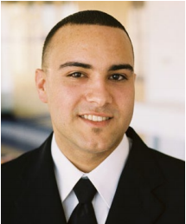
I wanted to share a little about my education and career path with you. I was born and raised in the Dominican Republic and when I was 17, my family moved to the United States. I was only one year away from finishing high school in the DR when we came to New York City, so I was not able to get my high school diploma. After we got settled in New York, I decided I wanted to go back to school, so I signed up for high school equivalency classes to get my GED. I had only just begun to learn English though, so I enrolled in classes that were taught in Spanish.
When it came time to take the GED exam, which is now called the TASC exam, I did great on the math portion. However, because my English wasn’t very advanced yet, I did not pass the English part. I was disappointed, but I believed that if I got some help with my English, I could retake the test and pass. So I signed up for ESL classes, where I worked hard for about eight months on improving my English skills, and when I took the test again, I passed everything! I was really proud of myself and it motivated me to keep moving forward.

I had always wanted to go to college, and my initial goal after getting my GED was to get into a community college to get an Associate’s degree, so I could get a better paying job with healthcare and retirement benefits. I didn’t really have a specific job in mind; I just wanted a good job that would allow me to live comfortably. So I decided to take some college preparation classes that would help me get ready to take the CUNY college placement exams.
However, when I went to take the placement exams, the same thing happened again—I passed the math, but I didn’t pass the writing exam. I was disappointed, but I was determined to go to college, so I kept studying and retook the exam and by the following semester, I was a student at Hostos Community College. When it came time to pick a major, I was unsure about what I wanted to study, so I chose a Liberal Arts and Sciences major which allowed me to take classes across a broad range of programs. All the while, I was volunteering at a hospital and began to think about a career in Occupational Therapy. I knew I liked helping people, but I wasn’t sure if the healthcare sector was the right choice for me.

During my time at Hostos, I worked very hard and earned a high GPA. I also got involved in the student Disability Club, and eventually became its president. My academic advisor at Hostos, who I talked to every now and again about how school was going and what I was thinking about for my future, told me about the CUNY College Discovery (CD) program for low income students. She told me that the program supported students who had financial and other challenges. I applied and was chosen to be part of the CD program, where I received tutoring to help with my English skills, career counseling, and networking opportunities with professionals. One of my favorite parts of CD was going to different activities where people who worked in all different kinds of careers would talk to us about their career pathways. This experience opened up my mind to the possibility that there was a lot more out there than I was currently thinking about. We got to meet with these professionals, speak with them one-on-one, and ask questions about their careers and how they achieved their goals. It really changed my thinking. Before then, I had only been thinking about the short term—get a good job with a good salary so I could be independent—but after participating in the CD program I really started to think about what kind of career I might enjoy long term.

I graduated from Hostos Community College with an Associate’s Degree in Liberal Arts and Sciences, and based on my experiences with social workers and patients, and meeting so many people through the CD program, I decided I wanted to pursue a career in Social Work. I applied to New York University and not only did I get in, but I was awarded a full financial scholarship as a transfer student! I received the scholarship as a result of my good grades and all the extracurricular activities and programs I had participated in at Hostos. My advisor at Hostos was always encouraging me to get involved with these different programs and said that colleges really like to see these kinds of things on students’ applications. And she was right! Because of the scholarship, I was able to focus on my studies at NYU and I graduated with a Bachelor of Science in Social Work.

SESSION THREE

SESSION THREE, ACTIVITY ONE: GRAPH HOMEWORK

Reading Graphs
Graphs show information visually and can summarize a lot of information quickly. There are different kinds of graphs including bar graphs, line graphs, and circle graphs.
- A bar graph organizes information along a vertical axis, which runs up and down one side. This vertical axis is usually referred to as the y-axis. A bar graph also has a horizontal axis. This axis runs along the bottom and is usually referred to as the x-axis.

- A line graph also has a Y and X axis and shows data on a continuous line.

- A circle graph is divided into pieces, like a pie. Each piece represents a different part of the whole. When the parts of a circle graph are expressed in percentages, the parts add up to 100 percent.

You will encounter graphs when you read. The graph might stand alone, or it might illustrate information in the article. When you read a graph you should examine the axes to see what information is being represented. Each graph has its own scale which is shown by the labels on the axes. The space between each number on the scale is called an interval.

Examine the graphs below and use the information you have read to help you complete the questions:
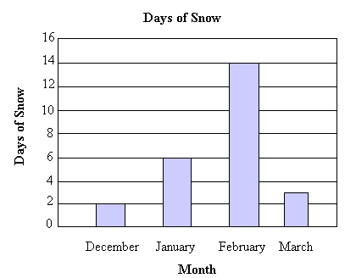
- What kind of graph is this? __________________________________________

- What information is being shown on the vertical axis? _________________________________

- What information is being shown on the x-axis? ______________________________________

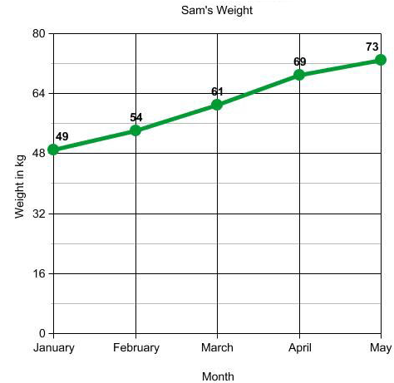
- What kind of graph is this? ________________________________________

- What information is being shown in the graph (be specific)?

______________________________________________________________________________

- What is the interval on the scale of this graph? ________________________

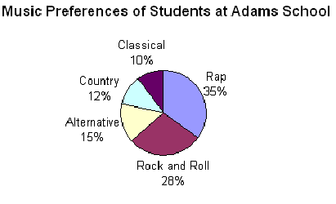
- What kind of graph is this? ______________________________

- What percentage of students prefer rap music? _______________________

- Which type of music is the least preferred among the students? _____________________________

SESSION THREE, ACTIVITY TWO: PAIRED READINGS

Rethinking Mistakes and Learning from your Missteps

Career Narrative: I Want to…Work at a Domestic Violence Shelter (Career Fundamentals, Unit 4, pp. 329-332)

Rethinking Mistakes & Learning From Your Missteps
By Margarita Tartakovsky, M.S.
Associate Editor
~ 3 min read

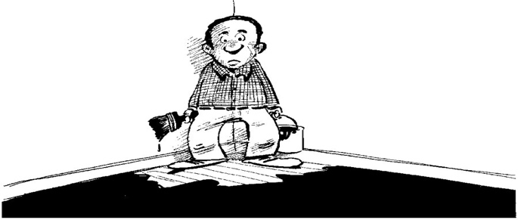

Many of us — though more likely most of us — fear making mistakes. And it makes sense. We live in a mistake-phobic society, according to clinical psychologist Wendy Mogel, Ph.D.
Take social media. We’re tempted to become our own publicists, she said. “We curate our persona,” rarely letting imperfections show (hello Facebook). Thanks to our 24/7 news media cycle, the smallest blunders get broadcast and picked apart by readers all over the world.
We also learn as kids that mistakes are bad. It’s better to get the answer right. The right answer leads to higher grades and scores, and greater success. And it’s a competitive world out there.
But mistakes are also valuable teachers, if we can only learn to listen.
One father told Mogel he fought with a pediatrician over his son’s Apgar score (and won). A kindergarten teacher recounted a meeting with two parents who complained the class curriculum wasn’t on the proper track for pre-med.
Mogel’s teen client was afraid to tell his mom he was writing a play. When asked why, he said, “Because she’ll get too excited.”
Mogel has worked with scores of parents who are afraid to let their kids make mistakes. It’s no wonder we try to minimize and mask our own imperfections.
And yet mistakes are essential steppingstones. They’re vital for growth and creativity. “[I]f we don’t focus on process over product, we cannot be innovators. We cannot learn about ourselves and learn about the world.”
Think of trial and error learning. “With no trial, there’s no error and no learning,” said Mogel, also author of The Blessing of a Skinned Knee and The Blessing of a B Minus.
And the reality is we’re going to make mistakes, said Alina Tugend, a journalist and author of Better By Mistake: The Unexpected Benefits of Being Wrong. “There’s no way to protect ourselves.”

The key lies in how we view mistakes – and what we do with them. Here are several strategies for rethinking mistakes and learning from your missteps.

Acknowledge your mistakes.

When making a mistake many of us deny it, get defensive, blame others or beat ourselves up, said Tugend, who also writes the ShortCuts column for The New York Times. These are natural tendencies. But they also prevent us from learning.
When beating ourselves up, we have a tendency to say everything from “I’m so stupid” to “I’m such a loser.” We view failure as permanent, and success as temporary, she said, stressing the importance of moving away from this sense of permanence.
“Beating yourself up over mistakes is actually a form of vanity, because it’s as though you’re supposed to be good at everything or always know what to do,” Mogel said.
When you make a mistake, take a deep breath and acknowledge it, Tugend said. Remind yourself that mistakes are normal. Perfection is a myth.

Mine your mistakes.

We tend to confuse reasons with excuses, Tugend said. In other words, sometimes we’re afraid to go into the reasons we made a mistake because we worry that we’re just making excuses.
But, sometimes, “there are valid reasons” behind our mistakes. And exploring those reasons helps you make important discoveries and improvements. It helps you set up systems to prevent mistakes in the future.
So explore your mistakes. Do you make this mistake a lot? Tugend said. If you do, how can you prevent it from happening next time? What kind of system can you set up?
If you forget to pay the cable bill every month, maybe you can create a reminder in your calendar a week before your due date, or set up an automatic withdrawal. Maybe your spouse is more organized, and you can delegate the task to them.
System changes have created positive results everywhere from the aviation industry to the medical field. For instance, implementing simple checklists along with instituting feedback and cultivating a culture of collaboration has saved lives, reducing medical mistakes at hospitals around the world.

Distinguish between valid and invalid criticism.

Sometimes we ignore the criticism aimed our way or internalize every morsel, Tugend said. Rather than taking an all-or-nothing approach, try to distinguish between valid and invalid criticism.
For instance, if you misspelled a prominent person’s name in an article, criticism that says you need to be more careful in the future is valid. However, criticism that says it’s solely your fault is not, because the editor and copyeditor also should’ve caught the error. The entire system may need to change, not just your actions.
It also helps to talk to someone you trust. Tell them what happened, and ask for their feedback in figuring out what’s right, she said.

Find a sponsor.

When Mogel works with parents on developing the courage to let their kids make mistakes, she suggests they find “a sponsor or one sane friend,” who isn’t caught up in the pressure for perfection, and “does not feel they have to have an inserted GPS into their child’s brain.”
Find one person who’s relatively unashamed and adventurous – without being reckless – about trying new things in various areas, she said.

Branch out.

“Instead of staying in the habit of doing the things you’re good at, learn something new,” Mogel said. Take a new class. Take up a new hobby. Try a solution that may not work. Practice taking chances and making mistakes.
We forget that mistakes can be instructive. “We know [from the research] that people who are allowed to make mistakes when they learn things often learn deeper and more comprehensively,” Tugend said.
Give yourself the opportunity to focus on the process, mine your mistakes and truly learn.

SESSION THREE, ACTIVITY FOUR: WORK AND EARLY HUMANS

EVENT STRIPS FOR STUDENTS TO SORT IN THE ORDER THEY THINK THEY TOOK PLACE:

Humans live in caves
Humans hunt to survive
Humans discover fire
Humans use stone tools
Humans use metal tools
Humans invent writing
Humans domesticate certain animals
Humans live in villages and towns
Humans learn to cultivate crops
Humans have different social classes
Humans develop religion

ARTIFACTS FOR STUDENTS TO ANALYZE:

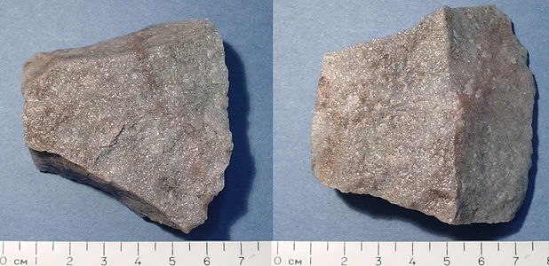

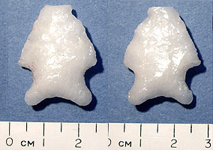 | 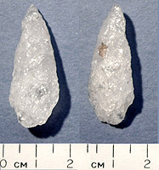 | 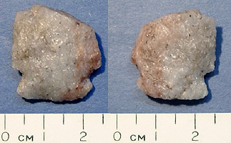

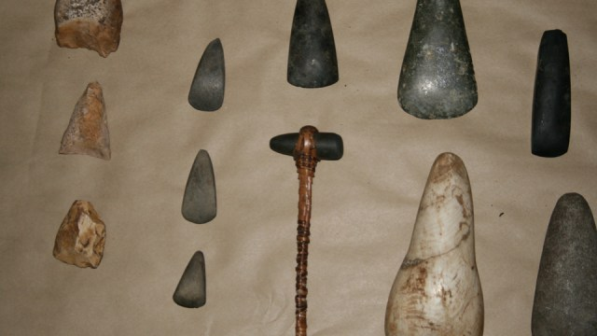

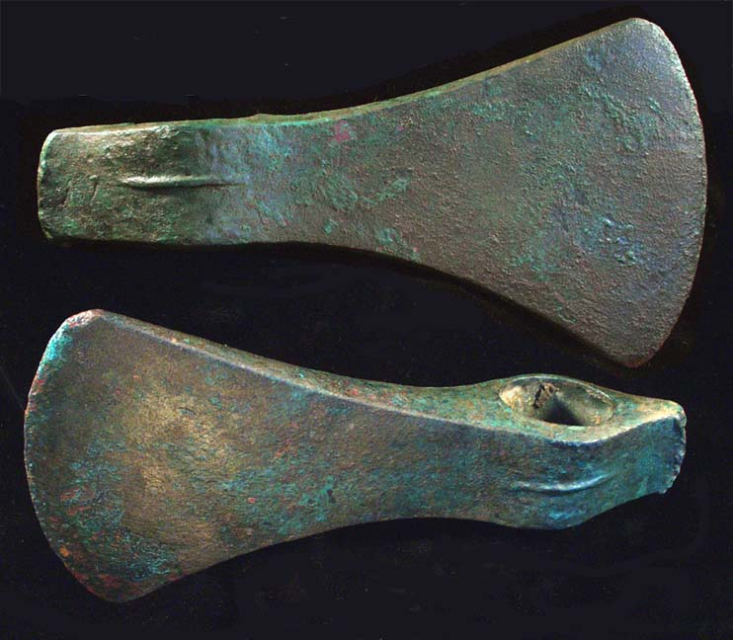
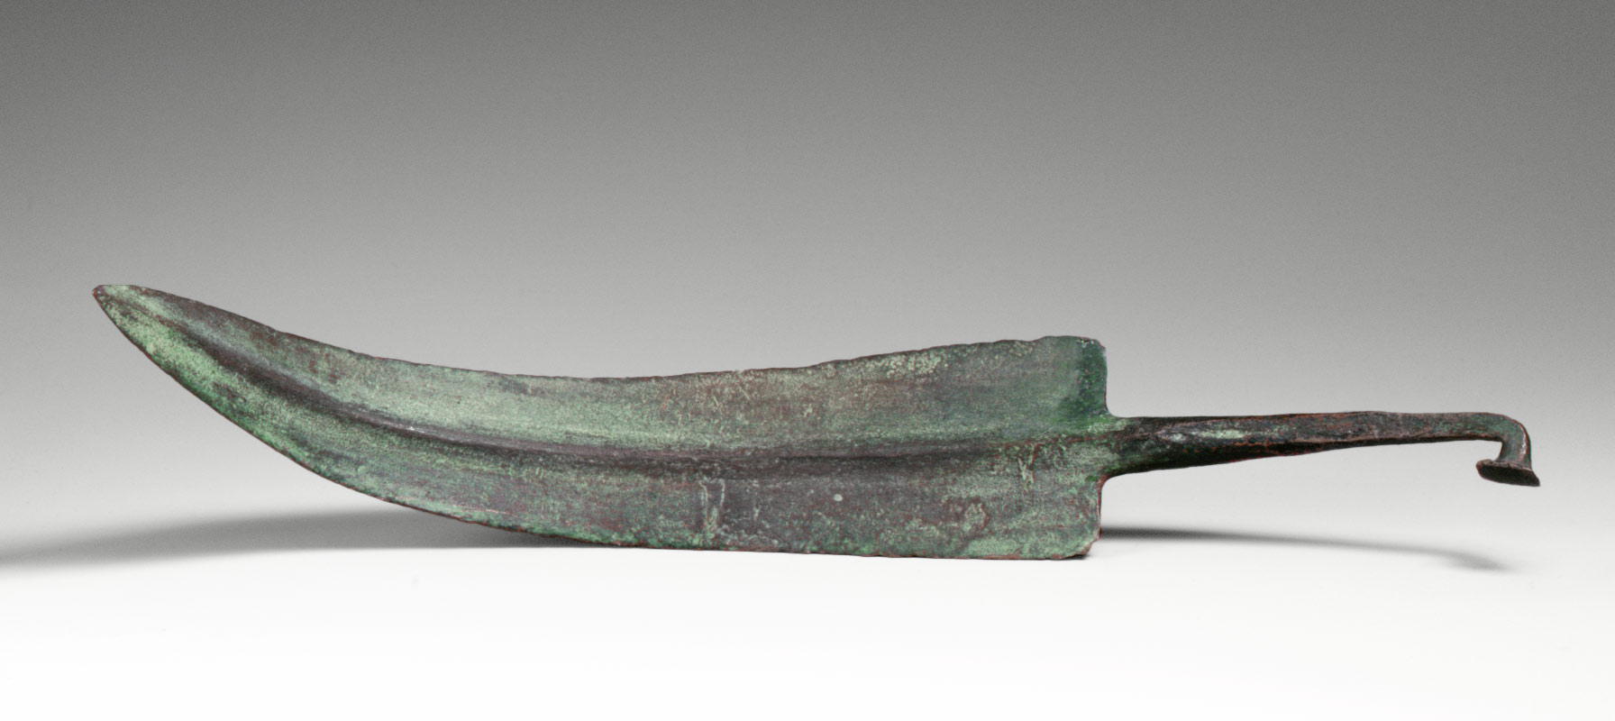
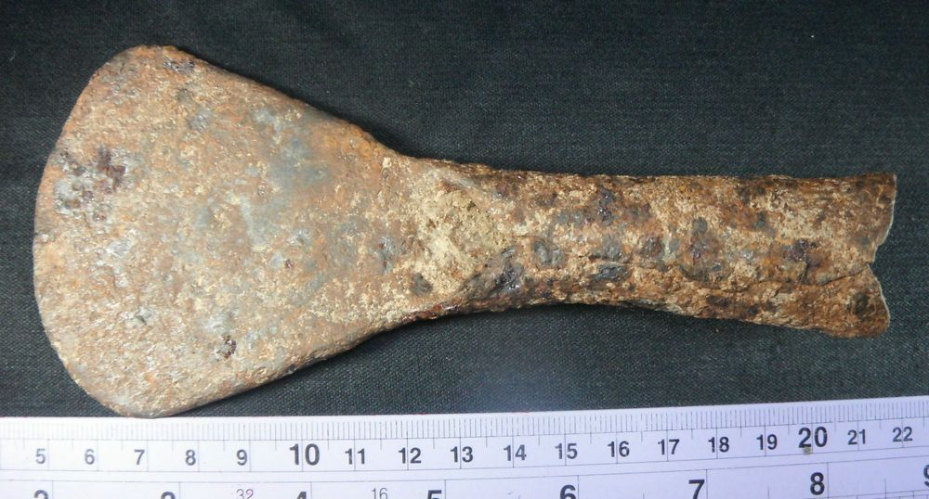
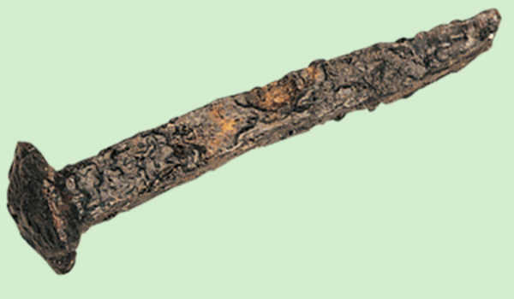

Analyze an Artifact

Meet the artifact.
Material (check all that apply):
Bone | Pottery | Metal | Wood
Stone | Leather | Glass | Paper
Cardboard | Fabric | Plastic | Other

Observe its parts.
Describe it as if you were explaining it to someone who can’t see it. Think about: shape, color, texture, size, weight, age, condition, movable parts, or anything written on it.

Try to make sense of it.
Answer as best you can.
Where is it from?
When is it from?
Who used it? List reasons you think so.
What was it used for? List reasons you think so.
What does this tell you about the people who made and used it?
What does it tell you about technology at the time it was made?
What is a similar item from today?

ARTICLE: THE EARLY WORLD AND ITS PEOPLE

The Early World and its People

About a million and a half years ago the surface of the earth began to change. Up to that time the northern part of the world had been covered by glaciers, or large, slowly moving masses of ice and snow. As a result, large areas of the earth’s surface were buried under sheets of ice. This period of cold weather is known as the Ice Age.

It took tens of thousands of years for the glaciers to move south. Then they melted slowly, until ice remained only in the far north. These glaciers formed, spread out, and melted away several times. All this started to take place about 1,500,000 years ago. The Ice Age ended about 25,000 years ago.

The first humans lived on earth more than three million years ago. Human life probably began in what is today eastern Africa. It took hundreds of thousands of years for humans to move across Africa to Europe and Asia.

Life was very difficult for the early humans. They spent most of their days gathering food from the ground, shrubs, and trees. Slowly, over a period of many years, the early humans learned to make and use tools and weapons. They passed these skills on to family members and to people whom they met.

The Ice Age glaciers forced the early humans to move southward. They finally settled in the warmer areas of the earth. These early humans looked something like us. But they differed from us in some ways too. Their ability to think and talk was not as highly developed as ours. As time went on, however, they increased their knowledge. The early humans learned to improve their crude, or simple, tools and weapons. 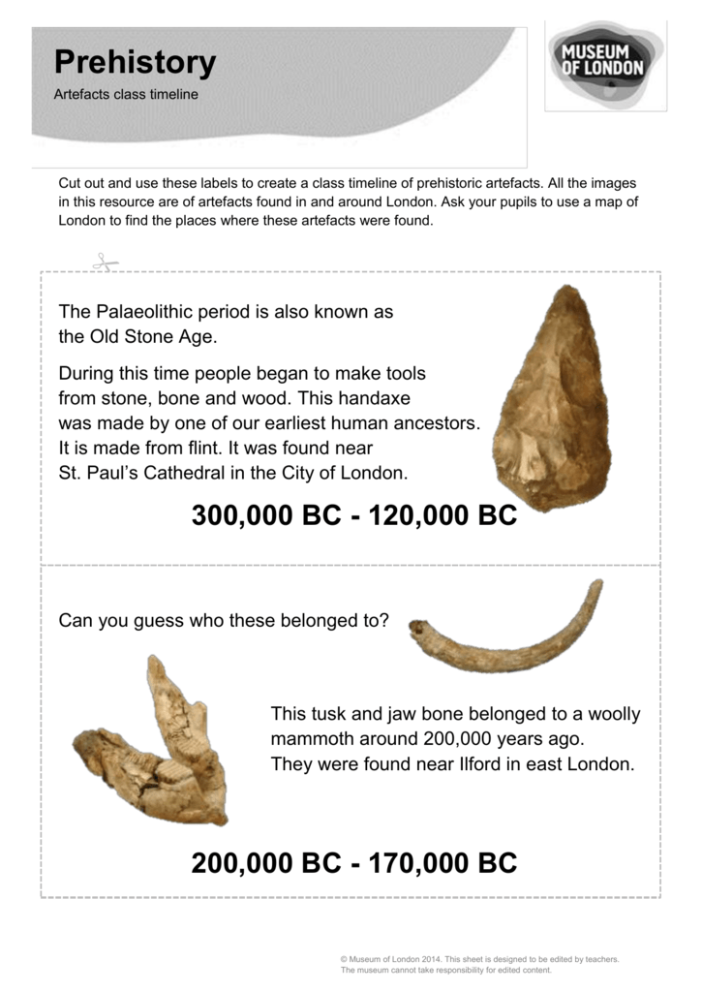

The Old Stone Age

About 150,000 years ago, people lived in what is now called the Old Stone Age. During the Old Stone Age, people made weapons and tools out of wood and stone. These weapons and tools included crude chisels, saws, hatchets, spears, and bows and arrows.

During the Old Stone Age, people fished and hunted for food. Later, they sewed the skins of the animals they killed to make clothes. The people of the Old Stone Age lived mostly in caves, and they used fire for warmth and cooking. They drew pictures of the animals they hunted on the walls of their caves. Most likely, they believed the drawings would bring them luck in hunting. The Old Stone Age way of life ended about 10,000 years ago.

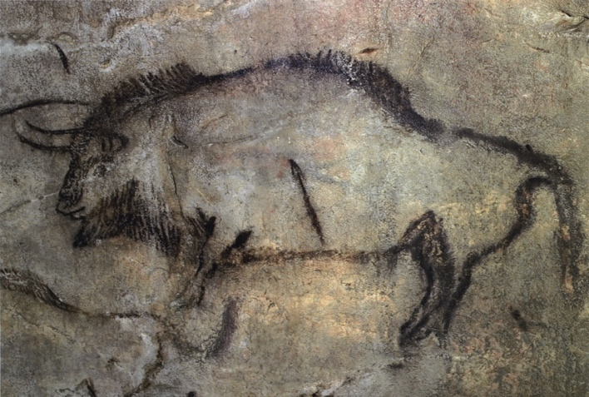
Next came the Middle Stone Age. This was the period from about 10,000 to 8,000 years ago. During this time, certain animals, such as dogs and goats, were domesticated, or tamed.

The New Stone Age

During the next 4,000 years, people lived in what is known as the New Stone Age. The people of the New Stone Age made many advances over the men and women who lived before them. They learned to farm, raise animals, and weave baskets. They made clothing from plant fibers and wool. They also made clay jars and pots to use for storing food. One of the greatest New Stone Age advances was the invention of the wheel. As time passed, the use of the wheel spread to many parts of the world. How do you think this spreading of culture came about?

Early humans continued to make many advances in living and working. About 6,000 years ago, people began making tools and weapons out of copper and bronze. About 2,500 years later, they began using iron for weapons and tools. In the years since then, iron and the products made from iron have been used to make everything from coat hangers to space ships.

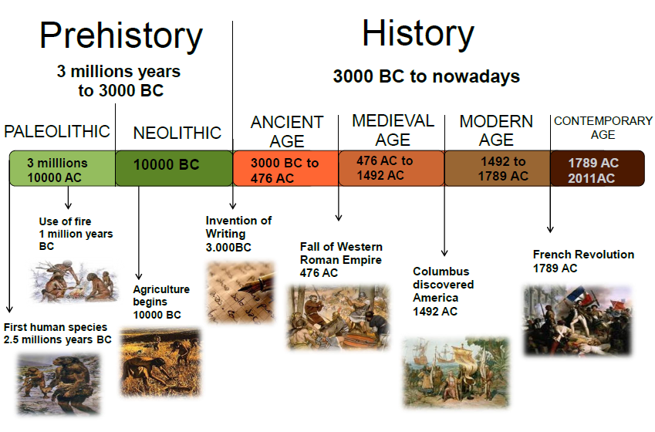

SESSION FOUR:

ACTIVITY ONE: TEST QUESTIONS AND GIST

Exercises for The World of Early Humans

- Finding the Main Idea

Put a check next to the sentence that gives the main idea of what you just read.

_____1. The invention of the wheel helped transportation.
_____2. People in early times made advances over the people who lived
before them.
_____3. The use of iron tools is a recent event.
_____4. The Ice Age began many years ago.

- What Did You Read

Choose the answer that best completes each sentence. Write the letter of your answer in the space provided.

_____1. The Old Stone Age began about
- 150,000 years ago.
- 10,000 years ago.
- 4,000 years ago.
- 1,000 years ago

_____2. During the New Stone Age, people
- Invented tools and weapons.
- Invented iron weapons.
- Discovered fire.
- Invented the wheel.

_____3. The world we live in is
- Very young.
- Very old.
- The same as it has always been.
- Full of glaciers.

_____4. Most likely, people of the Old Stone Age drew pictures of animals
- To frighten their enemies.
- To decorate their homes.
- To increase their success in hunting.
- To decorate their burial places.

- Organization of Ideas

List the following ideas in the order in which they appeared in the reading section. If necessary, you may look back at the text for help.

____ Old Stone Age people made tools and weapons out of stone and wood.
____ Most early humans settled in the warmer places on the earth.
____ The Ice Age glaciers took tens of thousands of years to move south.
____ About 1500 B.C., people learned to make tools and weapons out of iron.

- Time Skills:

Listed below are five historical items. Number each one in the order in which it took place on earth.

____ A. End of the Ice Age
____ B. The wheel is invented
____ C. Use of crude wood and stone tools.
____ D. Use of iron weapons and tools
____ E. Humans begin to tame certain animals.

ACTIVITY TWO: MAP WORK: THE CONTINENTS, CONTINENTS AND COUNTRIES, PHYSICAL MAPS

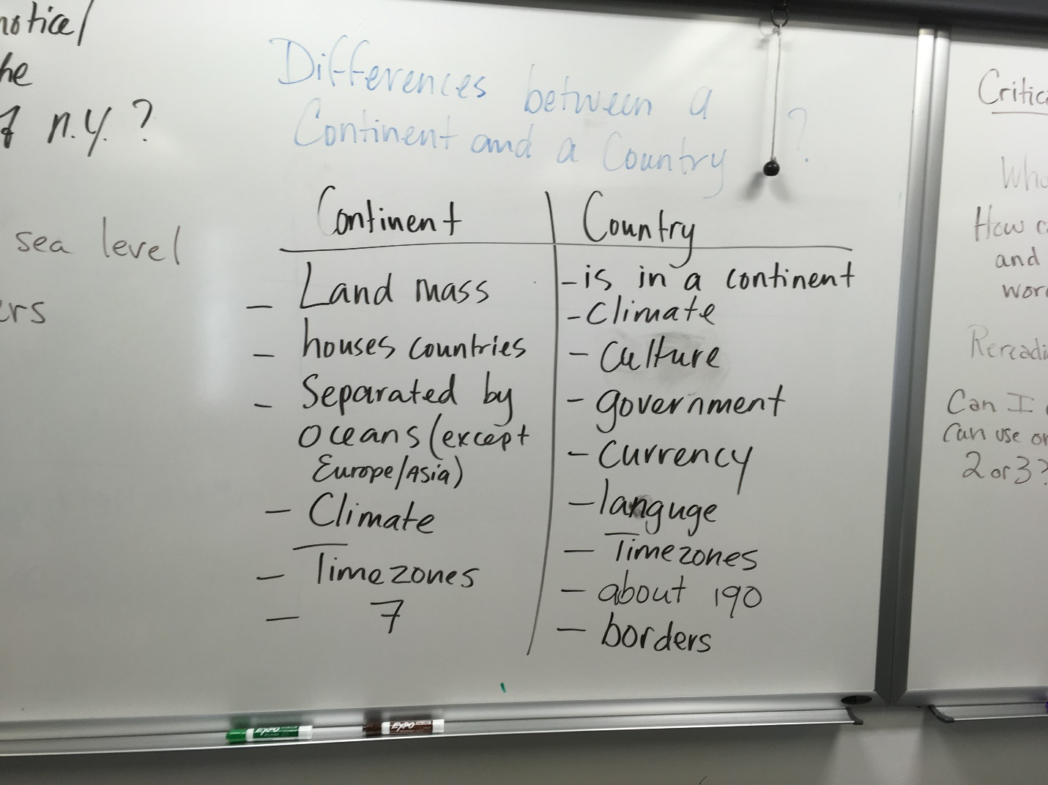
ACTIVITY THREE: HOMONYMS

CORRECT THE SENTENCES, HOMONYM LIST, HOMONYM EXERCISE

Homonyms
(Words that sound the same but are spelled differently)
accept | Verb meaning “to receive” (I accepted the gift with pleasure)
except | To exclude (Everyone except you)
advice | Noun meaning “words that help you out or tell you what to do” (I gave her good advice when her husband left)
advise | Verb meaning to give advice to someone (I advised her to think before enrolling in that class)
be | Verb meaning “to exist” (I hate to be blunt, but you don’t look good in that dress.)
bee | An insect (Some people are afraid of bees)
brake | To stop, or the part of a vehicle that makes it stop (I always brake for pedestrians)
break | Rest period (take a break) or damage and destroy (break the car) (Class has a 15 minute break).
for | To be used as (the spoon is for stirring); in favor of (I’m all for sports) ; it should belong to you (that book is for Tracy)
four | The number 4
knew | To be familiar with or certain of (I knew her when she was a baby) or (I knew she was going to fall) (verb; past tense)
new | Not old
know | To have information (I know all about science)
no | Opposite of yes; not (We have no shirts in stock(
lose | To fail to win or to keep (I lost monopoly and then I lost my car keys)
loose | Not tight (Her clothes were loose; or the door was loose)
one | The number 1
won | The past tense of the verb win (We won the game after 9 innings)
passed | Past tense of pass or went by (We passed the deli)
past | A time before (Our relationship is all in the past now)
right | Correct or opposite of left (You would be right if you said you use your right hand to say the Pledge of Allegiance)
write | To form words on paper (I don’t like to write letters)
roll | Verb: to turn over or noun: a type of bread (When I roll over in the morning I can barely get out of bed. Then my mother brings me a sweet roll and I have energy.)
role | A part to play (Conflict in the Middle East plays a role in oil prices).
sight | The ability to see (My sight isn’t good at night)
site | A place where something happens, including a website.
there | A place or a state of being (There it is). (There is a bad feeling here)
their | Belonging to them (Their grades were perfect)
They’re | Contraction of “they” and “are” (They’re going to be sorry when they see that mess.)
to | Used in front of a verb (I used to love her) or direction (She’s going to the store).
two | The number 2
too | Also or very (I would like to go too.) (It’s too hot).
wait | To stay around for something or someone (I will wait until you’re finished)
weight | How heavy something is (I’m really gaining weight).
way | Path, direction (That is not the way to get famous)
weigh | Verb: to measure how heavy something is (Let’s weigh the flour to see how much we’re putting into the bowl.)
where | What place (Where is class today?)
wear | To have clothing (What are you wearing to class today?
were | Past tense of are: Where were you yesterday?
whether | If (Let me know whether you’re going to the movies or not)
weather | Climate outside (Weird weather we’re having)
when | A time that something happened (When I went to school, there were no desks)
went | Past tense of the verb “to go.” (When I went to school, there were no desks.)
Your | Belonging to you (That’s your favorite song
You’re | Contraction of “you” and “are” (You’re looking good today)

Fill in the blanks. Use the correct form of the word.
- ___________________ we were, _________________ young women out on the town.
(there, their, they’re) (to, two, too)
- It was a Friday night. 3. We’d come out to ____________________ _____________ men we
(meet, meat) (to, too, two) hooked up with on an internet dating _________________________. 4. You ____________________
(site, sight) (know, no)
how it is—they were both full of stories about how they were looking _________ “chemistry.”
(for, four)
5. What can you do when ______________ in ____________ 30s and you’d really like to
(you’re, your) (you’re, your)
________________ with someone?
(be, bee) 6. We _________________________ the bar ___________________they said they
(passed, past) (where/were)
______________________ going to _________________. 7. I__________________
(where, were) (be, bee) (knew, new)

they might not be ______________________. 8. I told myself we were only going to
(they’re, there, their)
________________ 20 minutes and that was it. 9. That afternoon, before we had come
(wait, weight)

out, I was still wondering what to _________________________ and_______________
(wear, where) (whether, weather)

this was a good idea or not. 10. Well, they never came. 11. _____________was
(they’re, there, their)

___________ moment when _________________ men __________________ and I
(won, one) (to, two, too) (past, passed)

thought maybe that was them, but _________ go. 12. The worst part was, wouldn’t you
(no, know)

________________ it, it turns out later I would __________________________ my keys.
(no, know) (lose, loose)

13. What can you do? I _____________ it probably wasn’t my night. It’s not easy being a
(new, knew)

single woman—you go _____________ a lot. I guess you just have to _______________
(threw, through) (roll, role)
with the punches.

SESSION FIVE

SESSION FIVE, ACTIVITY ONE:

Feeling the Full-Bodied Joy of Students Who Got a Late Start
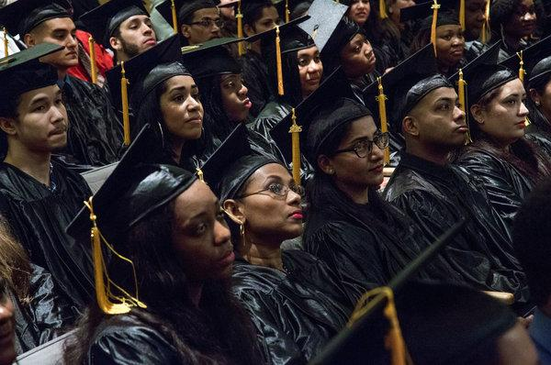
Graduates of an adult learning program run by the Queens Library received high school equivalency diplomas at a ceremony at the branch in Flushing on Tuesday.CreditCreditUli Seit for The New York Times

By Jim Dwyer of The New York Times
- May 10, 2016
Because Tuesday was going to be a big day, Jahangir Alam quit work an hour early and was home in Queens by 4 a.m. He slept fitfully, estimating later that he’d gotten an hour before his daughter, Mehrin, stirred for school. She is in sixth grade. Mehrin and the rest of the family — her brother, Tanveer, and Mr. Alam and his wife, Monira Alam — live in a one-bedroom apartment in Woodside, $1,700 a month.
Tanveer, 19, had a full day ahead at Hunter College, where he is studying computer science and completing his first year.
The parents were going to Flushing. Mr. Alam, who finished fifth grade in Bangladesh and has driven a yellow cab in New York for the past 20 years, was graduating from an adult learning program with a high school equivalency certificate.
Mr. Alam, 50, said that for decades he had felt the weight of its absence.
“Somehow, I couldn’t get it done in my country,” he said. “My son is the one who got me here. He went to Bronx Science for high school. He encouraged me every day. My wife, too.”
So on Tuesday, to the benedictional strains of “Pomp and Circumstance” in an auditorium at a branch of the Queens Library, Mr. Alam marched in a line with about 50 other adults who had also earned the certificates. In every conversation, they praised their teachers.
Rowdy jubilation is common enough at the graduations of young people from high school and college; it is a shadow of the full-bodied joy that lights up people who have come to their education later in life, even if it did not include beer-pong tournaments.

One woman from Guyana had stopped attending school to raise her children; another dropped out to help her parents, immigrants from Mexico. Afrania Gonzalez, 72, of Rego Park, Queens, said she had grown up on a farm in rural Colombia, where she went to work in a candle factory when she was 11. In New York, she worked as a cleaning lady and raised three children. After four years of study, she said, she planned to help friends and relatives as a translator.
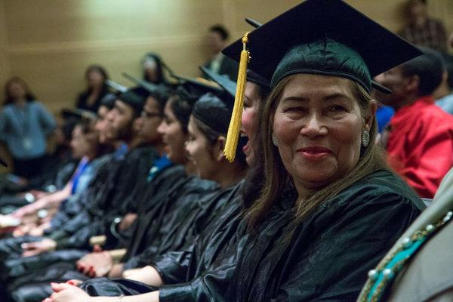
Afrania Gonzalez, 72, a native of Colombia who now lives in Rego Park, Queens, said that after four years of study, she planned to help friends and relatives as a translator.CreditUli Seit for The New York Times

For all of them, finishing high school meant taking classes at learning centers in library branches or community colleges, in between running their lives.
Mr. Alam said he was one of 12 children. Their mother died when he was very young. At school in the district of Narail, he moved in lock step with a brother. “My father said, ‘We don’t need two sets of books,’” Mr. Alam said. Around age 12, he found work in a department store. “I spoke English with the customers in the store,” he said.
In 1995, he and Ms. Alam moved to the United States. He took classes at commercial schools in Jackson Heights, but did not stick with them. Their son was on the way. “All this time, I asked: Why did I quit?” he said. “My wife was encouraging me to go back.”
He has worked a 12-hour shift, 5 p.m. to 5 a.m., five or six days a week for 20 years, he said, honing his English as a devoted public radio listener. “My education was WNYC radio, Leonard Lopate and BBC at night,” Ms. Alam said. “Brian Lehrer during the day. I get a lot of information from them. I give a little donation.”
As his son was getting ready for college, the endless nights, the drunk and disorderly passengers, were making Mr. Alam weary. He took Civil Service tests. He also found adult learning classes at LaGuardia Community College and at the Long Island City branch of the library. The schedule was brutal: all night driving the cab, then school during the day. His wife, who had two years of college in Bangladesh, and his son were his cheerleaders.
“She still feeds my son every day by hand,” Mr. Alam said. “He had a chance to go to university on Long Island. Stony Brook. We didn’t send him there because we want to live together. We’re not like you guys, age 17, you separate. She will feed him.”
In turn, the son, Tanveer, helped him. “I fell a little short on the math test,” Mr. Alam said. “Now I’m learning the basics of computer science.”
The moment would be celebrated by the four people in the little apartment in Woodside, and beyond.
“All my friends went to university,” Mr. Alam said. “Nobody understands how they’re educated and I’m not. They will be proud, too.”

Correction: May 10, 2016
An earlier version of this article misspelled the given name of Jahangir Alam’s son. He is Tanveer Alam, not Tambeer. The article also erroneously attributed a distinction to the Flushing branch of the Queens Library. It is not the main branch. (The system’s central library is in Jamaica.) The error was repeated in a picture caption.

SESSION 5, ACTIVITY TWO

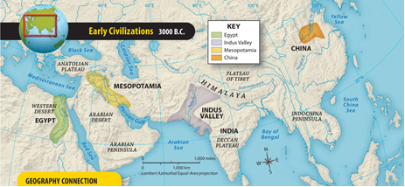

World History

How the Nile River Led to Civilization in Ancient Egypt
By USHistory.org, adapted by Newsela staff
03/07/2017
Word Count 720
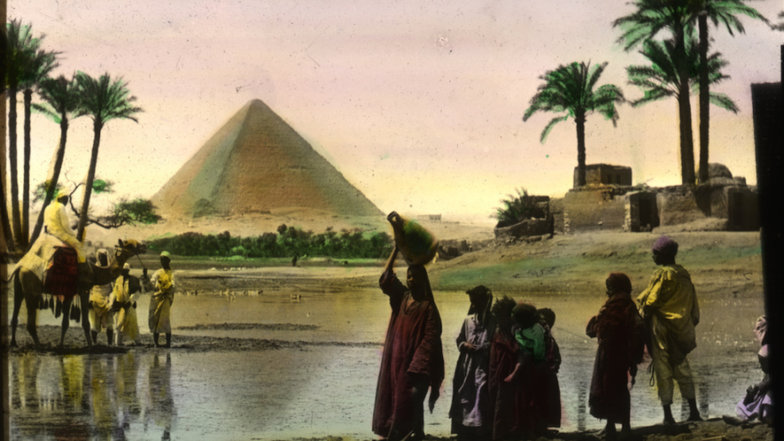TOP: This photo, taken around 1915, shows the flooding of the Nile River, which happens each year and makes the land in Egypt good for farming. If not for the Nile, Egyptian civilization could not have developed, as it is the only major source of water in this desert region. MIDDLE: A map of Egypt, courtesy of Wikimedia. BOTTOM: Cursive hieroglyphs from the Papyrus of Ani, from the Egyptian Book of the Dead.

The sands of the Nile River Valley hold many clues about the wonders of ancient Egypt. Much evidence survives about how the ancient Egyptians lived, though mysteries remain. Something we can know is that ancient Egypt had the five major hallmarks of civilization. These are cities, specialized workers, government, record keeping and new technology.
None of ancient Egypt's achievements would have been possible without the Nile. People started living along its river banks in about 6000 B.C., or about 8,100 years ago. But it wasn't until later that an organized civilization began forming. That's the conclusion of archaeologists and other experts.

Mostly desert
In 3000 B.C., Egypt looked similar to the way it looks today. The country was mostly covered by desert. But along the Nile River was a stretch of fertile land. This proved a source of life for most Egyptians.
The Nile is the longest river in the world. It flows northward for nearly 4,200 miles. In ancient times, crops only grew along a narrow, 12-mile stretch of land along the river. The area lacked forests or enough farm land. Still, a great society emerged.
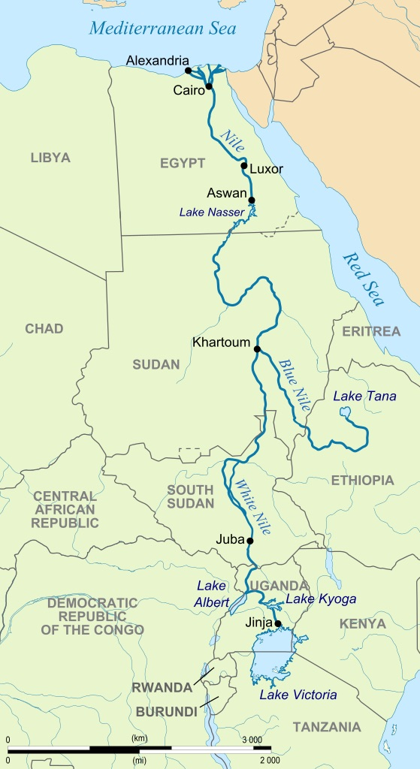
Food there was not easy to find. Over time, however, people learned that the Nile could provide plenty to eat. Along the river grew fruit trees, and the river itself was rich with fish.
Perhaps most importantly, they discovered that the Nile flooded for about six months. This happened every year at about the same time. As the water drew back after the flood, it left behind a rich, brown layer of silt. This soil was suitable for growing many kinds of crops, including beans and barley. Farmers dug short canals leading to fields near the Nile. These waterways provided fresh water for crops.

A growing civilization
Egypt's growing population required more planning and productivity. Farmers began growing extra crops. This allowed others to give up farming and work at other trades. They could become merchants or skilled workers. Such specialized labor is an important part of any civilization.
Egyptian inventors created new tools. These included copper chisels and needles. Metalworkers learned to mix copper and tin. This created bronze, a stronger metal. Evidence also suggests that ancient Egyptians invented the potter's wheel. This tool made it easier to make pots and jars for storage and cooking.
The calendar was one of the ancient Egyptians' greatest inventions. In order to know when to plant, the Egyptians needed to track days. They developed a calendar based on the flooding of the Nile that proved very accurate.

Setting themselves apart
How did the ancient Egyptians make their calendars? They developed a process that turned large reeds from the Nile into a flattened material. It is known as papyrus and could be written on. Among the first things Egyptians wrote down were calendars.
Writing helped set the Egyptians apart from neighboring lands. They used hieroglyphics, or pictures, to represent words and sounds. This allowed them to keep records for business and government, as well as write about their history.
Papyrus from the Nile had many other uses. Boats were constructed by binding the reeds together in bundles. Baskets, mats, rope and sandals were also made from this multipurpose material.
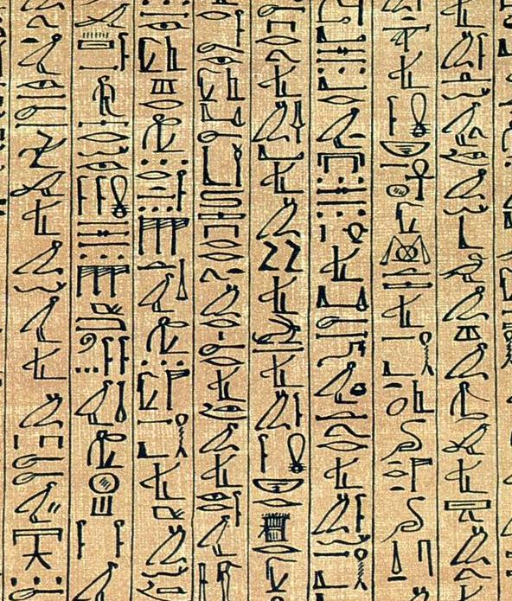
The landscape around the Nile is still quite barren today. Outside of the narrow band of greenery next to the river, there is sand as far as the eye can see. To the Nile's west stretches the Sahara, the largest desert in the world. East of the Nile are other dry lands.

Keeping enemies away
These deserts offered protection as the civilization of ancient Egypt grew. Few enemies could ever cross the dry sands to attack. After learning to take advantage of the Nile's floods — and not having to fear invaders — the Egyptians concentrated on improving farming and technology. As the years passed, Egyptians discovered that wheat could be baked into bread, barley could be turned into soup, and cotton could be spun into clothing.
With many of life's necessities provided, the Egyptians were free to think more about art, government, religion and philosophy. These are other elements of a civilization. The pharaohs emerged. These rulers led Egypt for about 3,000 years, and most were capable leaders. Eventually, pyramids and great cities became examples of this flourishing culture, one that lasted for several thousand years.

QUIZ QUESTIONS
Question One: Overall, the article is organized around:
A. definitions of important ancient Egyptian ideas
B detailed descriptions of daily life in ancient Egypt
C. explanations of how people created a civilization in ancient Egypt
D. examples that compare ancient Egyptian civilization with other civilizations
Question Two. How is the structure of the section "Mostly desert" different from the structure of the section "A growing civilization"?
A. The first section has a cause-and-effect structure, and the second section has a problem-and-solution structure.
B. The first section has a chronological structure, and the second section has a compare- and-contrast structure.
C. The first section has a problem-and-solution structure, and the second section has a chronological structure.
D. The first section has a compare- and-contrast structure, and the second section has a chronological structure.

Question Three. Which paragraph from the section "Setting themselves apart" BEST describes the importance of the last image in the article?
A. Paragraph One
B. Paragraph Two
C. Paragraph Three
Question Four. Based on the article, what do we know about Egypt and the surrounding area on the map?
A Without the Nile River, people never would have lived there at all.
B. Most people live farther from the Nile River now, unlike in the past.
C. Much of the land is desert, but the Nile River makes it possible for people to live there.

SESSON SIX

SESSION SIX, ACTIVITY ONE: TEST PRACTICE

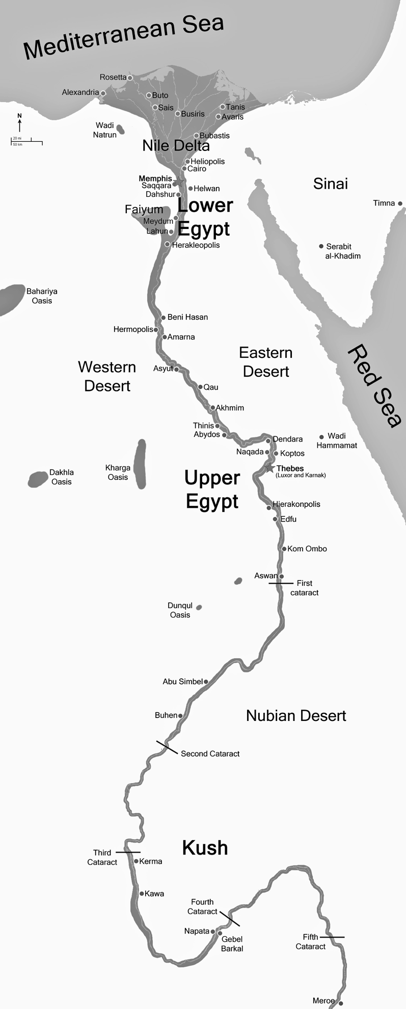
1. Ancient Egypt is sometimes called the Gift of the Nile because
A. The Nile is the world’s longest river
B. Fishing was one of Egypt’s largest industries
C. Egypt depended on the mile for transportation
D. The Nile’s annual floodwaters made agriculture possible.

2. The placement of cities on this map shows how the development of early civilizations depended heavily on
A. mountains
B. access to water
C. stone architecture
D. religious monuments

3. The primary reason ancient peoples of the Nile River valley built levees, dikes and reservoirs was to
A. purify sacred waters
B. create a shorter route to distant cities
C. defend against invaders
D. increase agricultural production

Base your answers to questions 4 and 5 on the model below and on your knowledge of social studies.
Egyptian Model

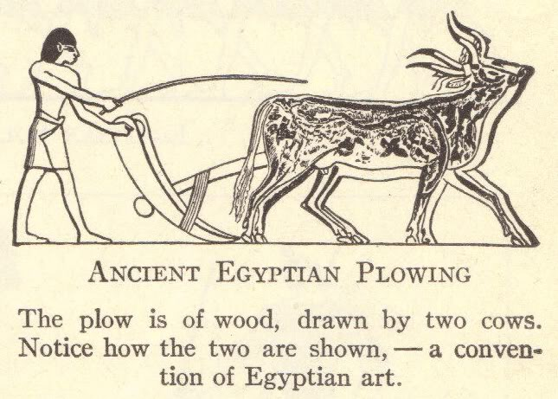
4. The activity portrayed in this model could be used as evidence to argue that Egyptians
A. lived in settled communities
B. relied on slash-and-burn technology
C. practiced hunting
D. engaged in foraging

5. An examination of this model would suggest that
A. peasants were excluded from political activity
B. the society lacks a social system
C. art can provide an understanding of history
D. everyday life is based on religious beliefs.

Read the passage about The Indus River Valley Civilization, then answer the questions.

The First Great Civilization of the Indus River Valley
Harappa was the first great civilization of the Indus River Valley. This Indus River Valley spread across what is now the country of Pakistan and the western part of India. The mysteries of Harappan culture were hidden from us for thousands of years.
Harappa grew at the same time as ancient Egypt. The Egyptians, as well as other cultures like the Mayans and Chinese, left many things behind for archaeologists to find. Archaeologists study ancient objects to learn about how people lived in the past.
Almost no trace of Harappa had been found until the 1920s. Discovering what Harappans left behind has totally changed our idea of early humans.

Farming grows out of a gathering culture
Vasant Shinde is an archaeologist. He studies Harappa. At a special event in 2013, he spoke about the rise and fall of Harappan civilization.
Around 7000 to 5000 B.C., people began to farm their own food, instead of just gathering it. From 2600 to 1900 B.C., its cities and people were at its strongest. They started to think of themselves as one shared civilization, and they were peaceful. In 1900–1300 B.C., Harappa declined. The area split up into different parts.
The Harrappa findings changed how we think about how farming began. In the past, it was believed that travelers from places such as Egypt and Mesopotamia brought farming methods and tools to the Indus River Valley. That idea is now known to be false, Shinde said.
Harappan cities “don’t have large monumental buildings,” he said. But these cities were still "clean and well-planned."
The Indus River Valley Civilization was the largest of the four ancient civilizations of Egypt, Mesopotamia, India and China. However, of all these civilizations the least is known about the Indus Valley people. This is because the Indus script has not yet been deciphered. There are many remnants of script on pottery vessels, seals and amulets, but without a “Rosetta Stone” linguists and archaeologists have been unable to decipher it.
Many things found in Harappa are now the oldest known examples of certain traditions.

Harappan society was more advanced than once thought
It is difficult to say for certain how or where these ideas began. However it happened, the Harappan discoveries show that south Asia was a far more advanced civilization than people knew.
Here are just a few things the Harappans did before anyone else:
• They carefully mapped their cities, and had streets facing north, west, east and south.
• There is no evidence of slavery, yet there are signs of cooperative, organized rule.
• Harappans collected rainwater and used wells and drains to move water.
• They traded and communicated with faraway places, like Mesopotamia.
• They invented new forms of metalwork and pottery.
The Indus River Valley Civilization was the largest of the four ancient civilizations of Egypt, Mesopotamia, India and China. However, of all these civilizations the least is known about the Indus Valley people. This is because the Indus script has not yet been deciphered. There are many remnants of script on pottery vessels, seals and amulets, but without a “Rosetta Stone” linguists and archaeologists have been unable to decipher it.
6. Read the summary of the main ideas in the article.
Archaeologists have been discovering artifacts of the Harappan civilization since the 1920s. These discoveries show an advanced, highly organized culture in the Indus Valley.
Which option below would complete the summary?
A. Innovations such as wells, new metalwork, and carefully mapped cities were pioneered by the Harappans.
B. The Harappans were originally thought to be less advanced than the Egyptian and Mesopotamian cultures.
C. Evidence of contact with other cultures has been discovered in Harappans.
D.The Harappans are also thought to have had elected leaders.

7. Based on this passage, what is a valid conclusion about civilization in the Indus Valley?
A. Lack of a Rosetta stone has hindered linguists from deciphering Indus Valley script.
B. The small amount of pottery vessels and seals from the Indus Valley indicates limited urban development.
C. The Indus Valley civilization controlled a territory that extended from western Europe to China.
D. Artifacts suggest the Indus Valley civilization is older than the civilizations in Egypt and Mesopotamia.
8. Discovery of streets arranged in a grid-like pattern and a system of pipes for moving water in Harappa and its “sister city” Mohenjo-Daro suggest that these ancient river valley cities in South Asia had
A. organized governments
B. subsistence-based economies
C. polytheistic beliefs
D. rigid social classes
9. What did early civilizations on the Indian subcontinent have in common with ancient Egyptian civilization?

A. Both had indoor plumbing
B. Both were centered near rivers
D. Both built large religious monuments
C. Both began around 2500 B.C.

10. The economies of the ancient Egyptian and Indian subcontinent civilization were dependent on
A. agriculture
B. hunting
C. manufacturing
D. trade

SESSION SIX, ACTIVITY TWO: Writing: Constructive Feedback and What is a Sentence?

Dear Students,
I wanted to write to you and explain a bit about the way I teach writing.
I am a writer myself, so I feel very strongly about the teaching of writing. I have been writing all my life, and I still write a lot—at least nine hours per week. I have been working on a book for a long time. It’s a lot of work, but I don’t want to stop. Writing is my way of meditating. When I write, I don’t think about my “to do” list. I go into a “zone” where I am only thinking about what I am creating on the page.
When I was younger, writing was also a way for me to survive. For a long time, I was very depressed. I would find it very hard to get out of bed in the morning, and I didn’t feel much hope. Writing helped me survive, because during the time that I was writing, my mind was not on my troubles. Writing also helped me figure out why I had some of the emotions that I had. I remembered things from my past very clearly and made connections between mistakes I had made and the experiences that led me to make those mistakes.
I think that writing can help a person in a lot of ways. When you write, you express your feelings. You get a clearer idea of what you think, what you feel, and why. It helps you to be more articulate and precise when you speak to other people, and this ability makes people respect you and listen to you more attentively. When you can be more articulate, you are more confident about speaking out, and have a good chance of becoming less frustrated by the barriers you face. I can’t tell you how much my ability to write well and easily has helped me at work.
When I teach writing, I think about the things that have helped me as a writer. One of the things that has helped me the most is constructive feedback. “Feedback” means that people tell you what they thought about your writing. “Constructive” means they tell you what they like, what they want to know more, and what they didn’t understand It also includes suggestions to make a piece of writing stronger. I can’t tell you how much I have rewritten something so that it says what I want it to say. Usually I do this after receiving constructive feedback.
One of the first things I do when I teach writing is tell you what I like. Below, you will find the lines that I liked most from each of your writing assignments from last class. The assignment was to write a letter of advice to another adult student who is thinking of taking an HSE prep class. Here are my favorite lines:

- I remember you telling me that you think it is too late for you to go back to school but I’m here to tell you that it’s never too late for you to earn your GED and earn a good income.

- I put myself to this point of view because I dropped out, gave up and I’m trying to achieve what I gave up. I’m in a program to achieve my GED now and until I have accomplished my GED I won’t quit.

- Lajoie, you say without this HSE it felt like a weight of massive absence. This is the time to start a new beginning to take this massive weight of absence and turn it into positive and great goals.

- I would like to tell you that I am going to school at BMCC. I know it may surprise you because I have two sons and I have to work. How is it possible? Of course it is not easy for me, but I really enjoy when I am in school.

- You can prevent yourself from overworking every day. Have a calm mind and you will be able to get the work done in time.

- Having a diploma sets an example of yourself on how far you have come. It’s the first step in your future to find that light at the end of the tunnel.

- To be completely real and honest, this journey back to scholastic land has been one of the most difficult undertakings of my life. However, it pales in comparison to the joy, confidence, self-worth and empowerment that is permeating my life.

- I’m going to class now for myself and it does suck (I said I wouldn’t lie) but it’s sometimes fun. You get to be social with others who are going back after many years and age hasn’t really stopped them from knowing they can do it.

- I overheard a story the other day and I thought I would share it with you. A middle aged woman really wants to go to medical school but she feels she is too old. Her friend says,” how many years will it take you to become a doctor?
“Ten years say the woman.
“How old will you be when you become a doctor?” she asked.
“Fifty,” said the woman.
“You are not too old if you are talking about something that will allow you to do what you really want to do, said the friend.

- Think about how your life would change if you earn your HSE. You’ll have better salary, better living. You just got to have faith in yourself. I know you can do it. Put your thinking cap on and get to work.

- Don’t give up because there’s always a solution to every problem. Always remember that with perseverance, determination and a set goal you can and will accomplish everything that you put your mind to.

- If you take the TASC test and you pass, you’re gonna get a good job.

Here are some other things I do when teaching writing:
I try to write a note to each student individually, or sit with you to tell you what is strong and what you need to work on. Every student usually needs to work on something different. If English is not your first language, learning to write is quite a challenge. You may need to work a lot on grammar. Sometimes people also need to work on how to structure their writing—to organize it so that it makes sense or is more effective. I might also ask you more questions because I want to learn more about what you were writing about, or I think it would add to the writing if you include more information.

If there is a type of error that most of the students in the class are making, we will work on that as a class first. Then I will ask each student to correct that error is her or her own writing. My wish for you is that you improve as writers, and start to love it as much as I do. It’s a lot of work but worth it in the end.

Welcome to the Writing Club!

Your teacher,
Kate

Correct the sentences below.

- I heard you’re thinking about coming back to school for your GED test I really think you should it’s all worth it in the end.

- My advice is to be prepared; and in my opinion, is to study really hard and focus.

- The program that I attend helps you a lot the teachers are very friendly they prep you for the TASC test.

- I know you can do it put your thinking cap on and get to work.

- I found some great information about you getting your GED that I think you would love to hear about, I remember you telling me you think that it is too late for you to go back to school but I’m here to tell you that it’s never too late for you to earn your GED and earn a good income.

- Friend, never give up on yourself always look to the positive and if you accomplish your goal think how great and positive changes will come to your life.

