Write down everything you can about this 3x3x3 shape. What do you see?

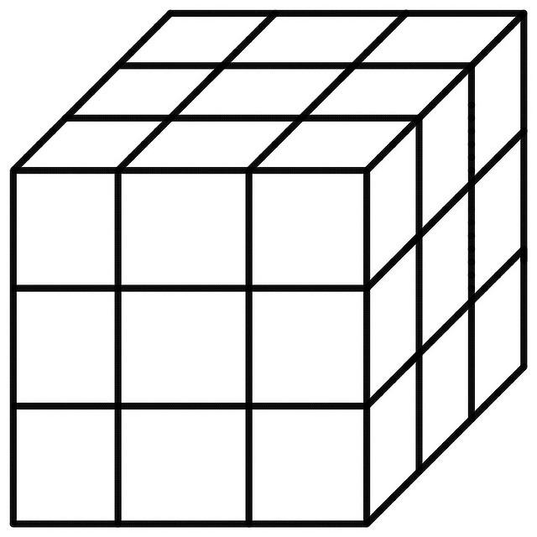

What questions do you have about it?

The Painted Cube

Using 1-inch red cubes, Sally builds a 3x3x3 cube. Then, she paints all of the faces of the big cube with yellow paint. After she does this she wonders if every side of each 1-inch cube is also painted yellow. So, she breaks it back down into 1-inch cubes to find out. What do you think?

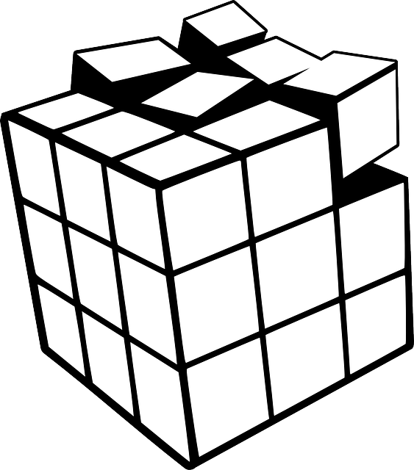

Write down as much as you can about how many faces are painted on each 1-inch cube.

Support and Push Cards
Can you make a model of the cube? | How many total 1-inch cubes are in the 3x3x3 cube?
How many faces are painted yellow on each of the 1-inch cubes that are in the corners of the 3x3x3 cube? | Where would 1-inch cubes with no faces painted yellow be? How many are there?
Sherri thinks that there are twelve 1-inch cubes with 2 faces painted yellow and Connie thinks that there are eight 1-inch cubes with 2 faces painted yellow in the 3x3x3 cube. What do you see? | How many of the 1-inch cubes have more than 3 faces painted yellow?
How many of the 1-inch cubes have exactly one face painted yellow? | How many cubes would have 3 faces painted if the cube is  2x2x2?
How many cubes would have no faces painted if the cube is  4x4x4? | How many cubes would have one face painted if the cube is 4x4x4?
Can you write a rule to determine the number of cubes with 2 yellow faces if the cube is n x n x n? | How many cubes would have two faces painted if the cube is 4x4x4?
Fill in the following table:  Side Length of cube Number of cubes with 2 faces painted  2 x 2 x 2  3 x 3 x 3  4 x 4 x 4  5 x 5 x 5 | Fill in the following table:  Side Length of cube Number of cubes with 3 faces painted  2 x 2 x 2  3 x 3 x 3  4 x 4 x 4  5 x 5 x 5
Create a graph that represents the number of cubes with 2 faces painted. Put the side length on the x-axis and the number of faces painted on the y-axis. | Create a graph that represents the number of cubes with 3 faces painted. Put the side length on the x-axis and the number of faces painted on the y-axis.

You can access a Google Slide Presentation for classroom use here.

Note: These cards are not divided so that some are Push questions and some are Support questions, since they can be used either way depending on the student. Also, some cards do not have a numeric value so they can be used with any size cube.
This version of The Painted Cube with Support and Push Questions was adapted from The Paycheck Problem and Surface Area of a Filing Cabinet at www.CollectEdNY.org.

Patricia Helmuth: mathpractitioner@gmail.com

