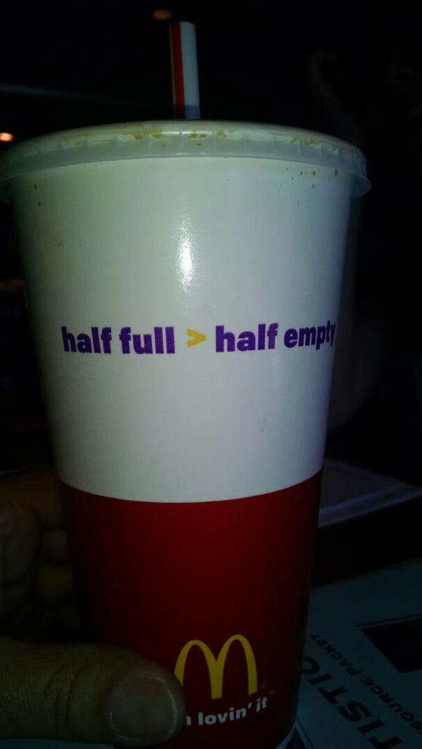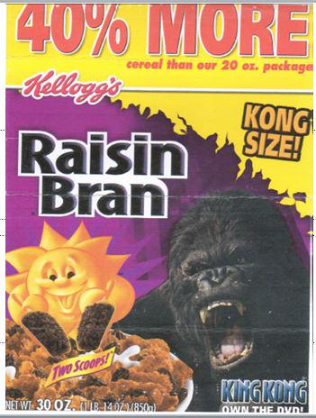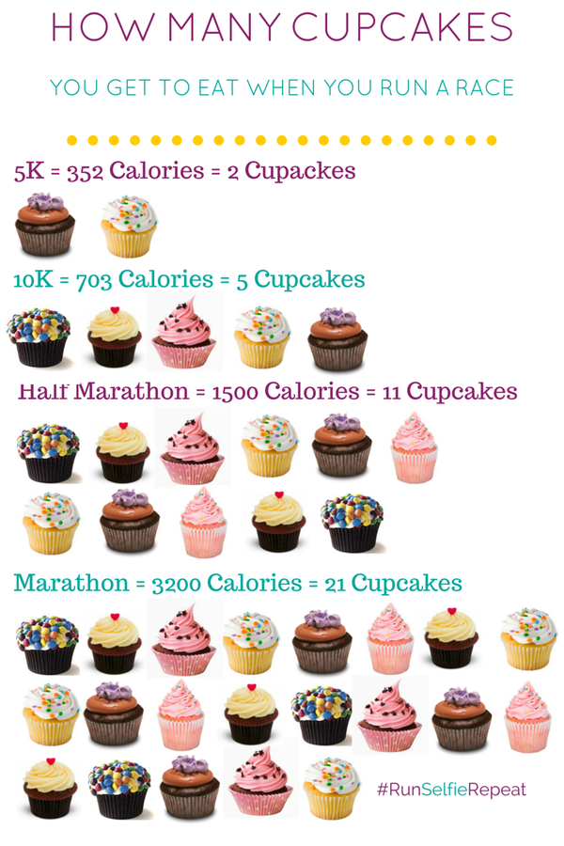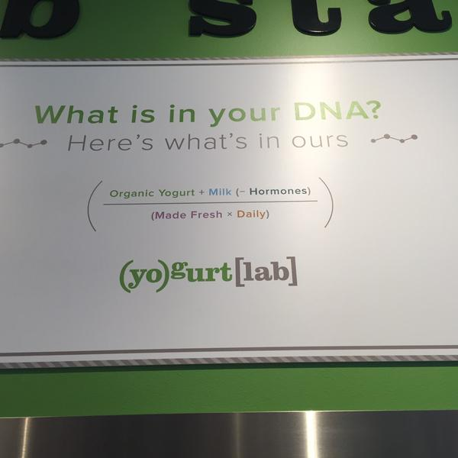

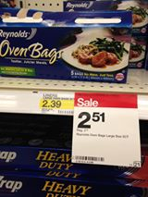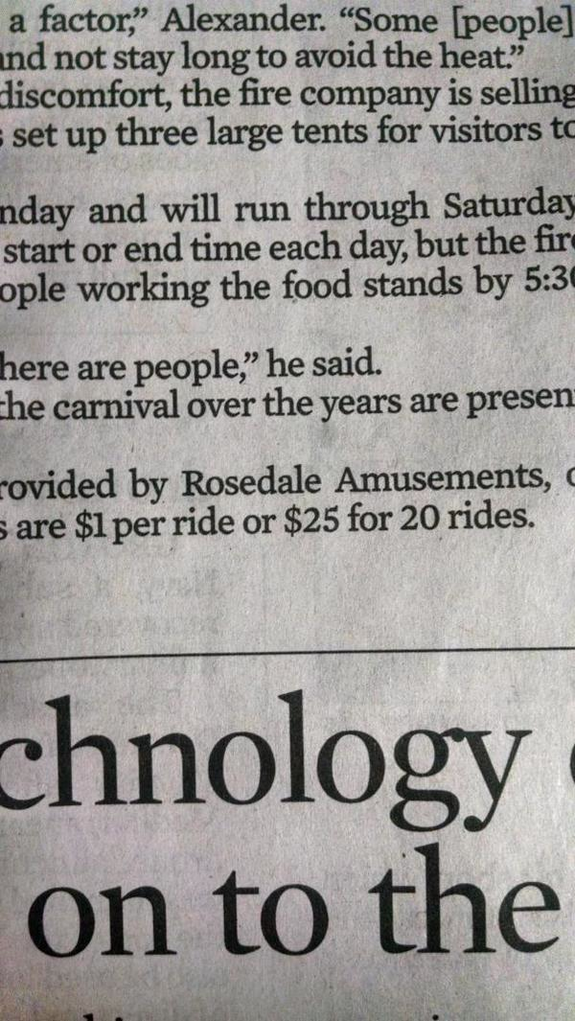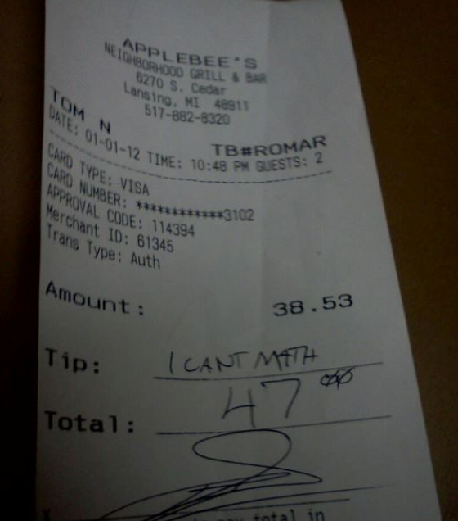



[](https://o.twimg.com/2/proxy.jpg?t=HBggaHR0cDovL2kuaW1ndXIuY29tL1hVRmQ3WW8uanBnPzEUwAcUwAcAFgASAA&s=S7Qb4W9LCvbMC_74E1-8u0jim6FxuMjAuSwMuy5gDqI)

[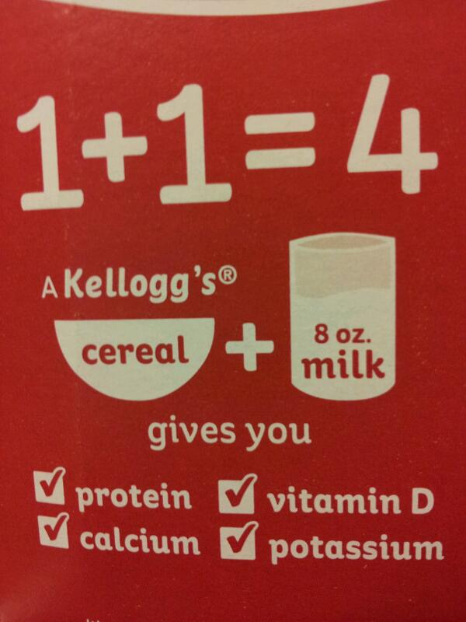](https://twitter.com/antoniocsulb/status/379440967058599937/photo/1)

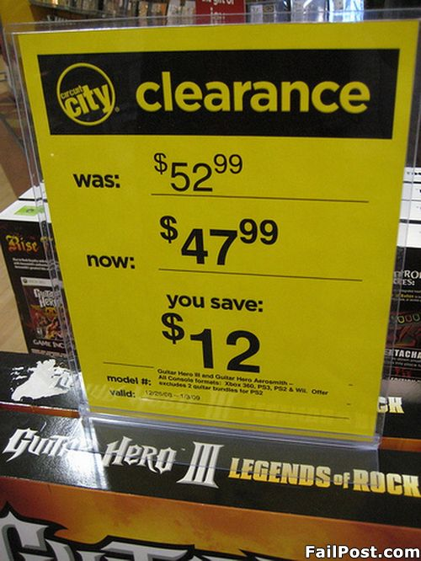



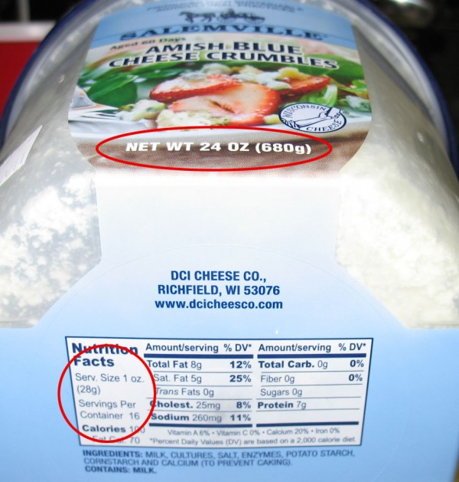

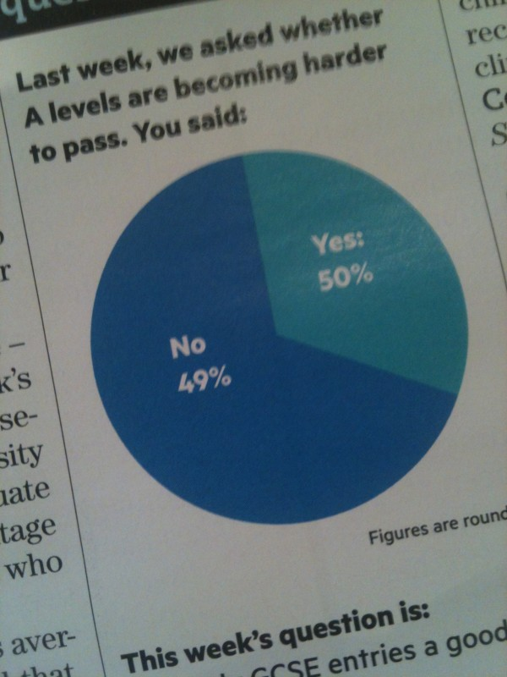

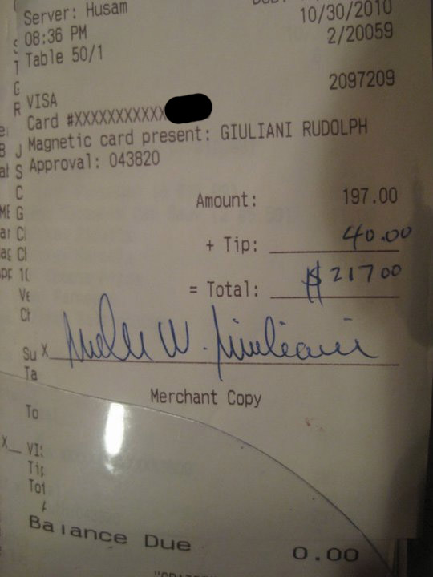

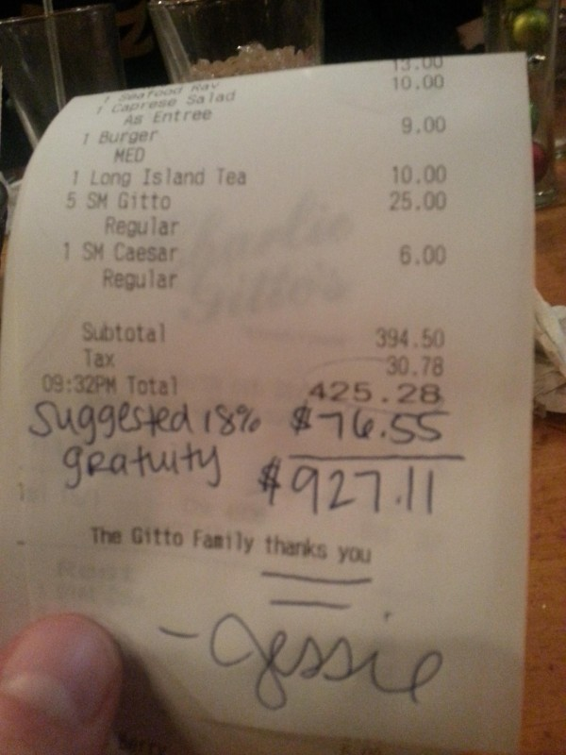

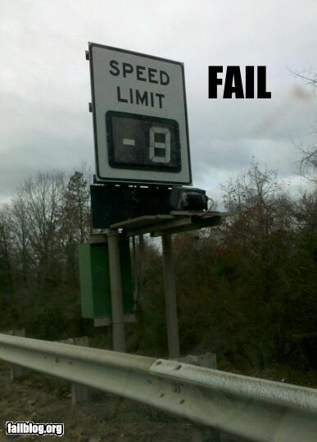

[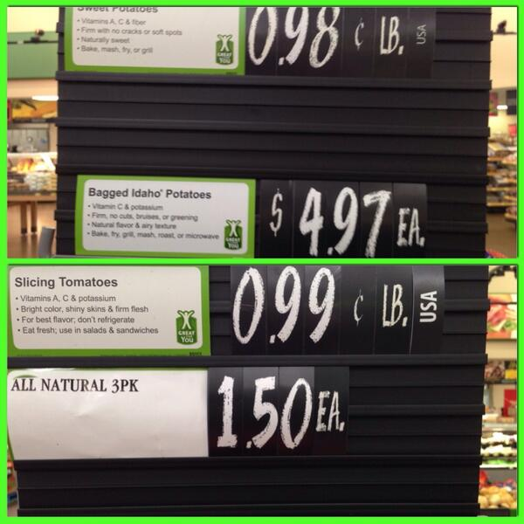](https://twitter.com/LukeSelfwalker/status/482935859013242880/photo/1)

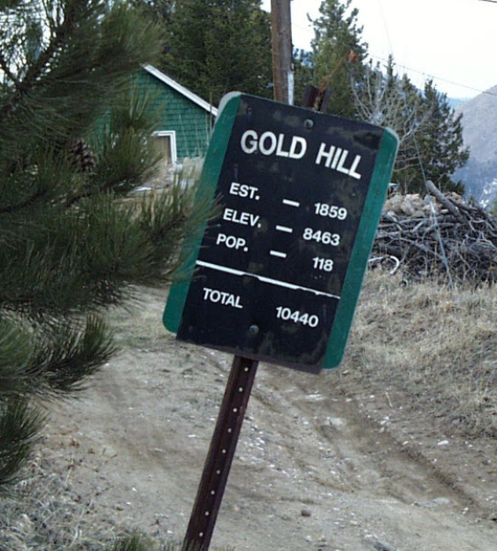



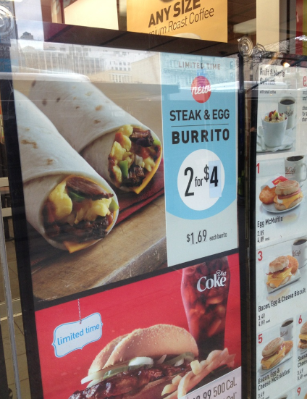

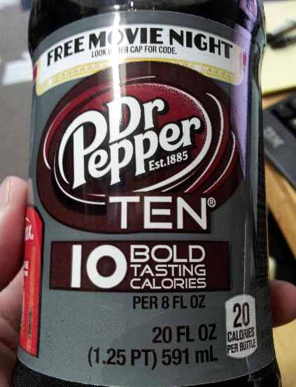

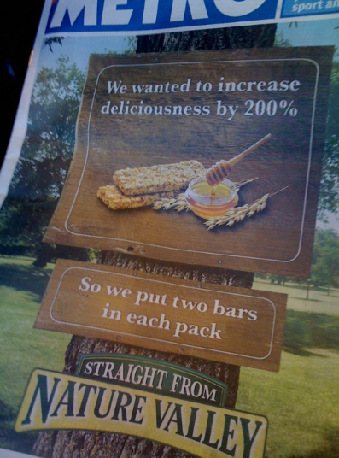

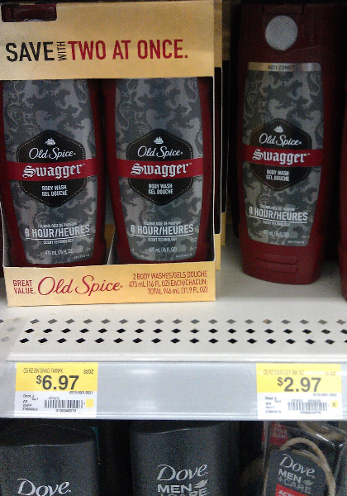



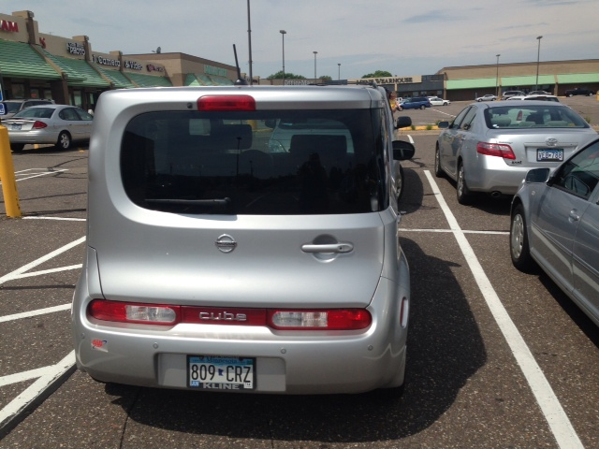

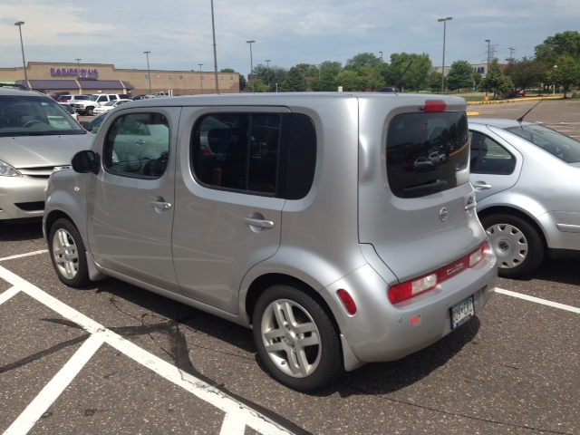



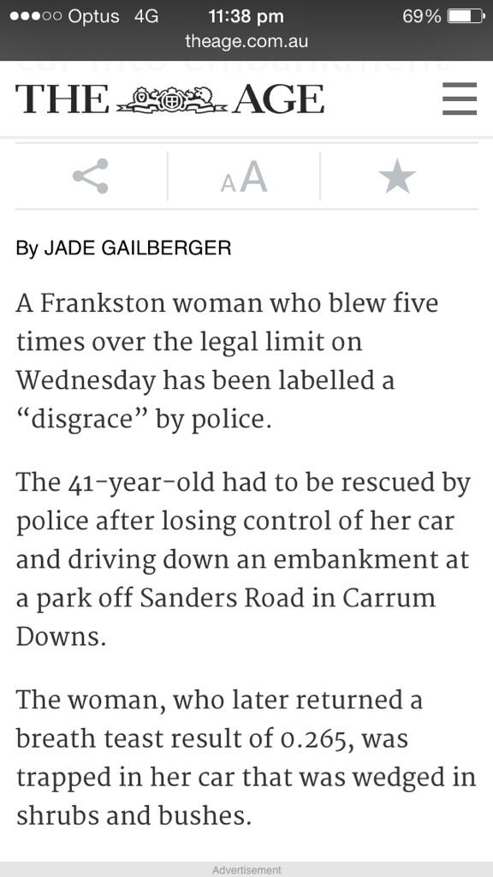

[](http://www.google.com/url?sa=i&rct=j&q=&esrc=s&frm=1&source=images&cd=&cad=rja&uact=8&docid=iYZyofVh8nn9PM&tbnid=OoYT2e8knlxZJM:&ved=0CAUQjRw&url=http://m.awrestaurants.com/m_geo_front.php?op=mloc&mlat=&ei=LCDhU7OFLtL8oAT6noCIDQ&bvm=bv.72197243,d.cGU&psig=AFQjCNHFrk6MscaDmWorzrW0SNmo9FbBVQ&ust=1407349154953505)[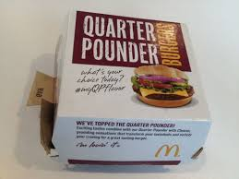](http://www.google.com/url?sa=i&rct=j&q=&esrc=s&frm=1&source=images&cd=&cad=rja&uact=8&docid=rM035rDaIggI-M&tbnid=urOG29Ejo0ZPDM:&ved=0CAUQjRw&url=http://www.grubgrade.com/reviews/review-bacon-habanero-ranch-quarter-pounder-from-mcdonalds/&ei=KCHhU-6TLM_3oAT5_4DIAw&bvm=bv.72197243,d.cGU&psig=AFQjCNEhtvXBfvOQbslNcIsHqc2zH21zbw&ust=1407349387677990)

