WARM-UP
Write down as many things as you can about this figure. What do you see?

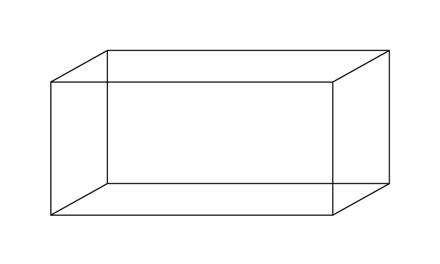

Push and Extension Questions
Draw a picture of one face of the file cabinet. How many sticky notes would fit across? How many sticky notes would fit going down? | Draw and label a picture of one face of the file cabinet. What is the area of that face? How many sticky notes would you need to cover that area?
How many square inches does it take to cover one Post-It note? | What is the surface area of the file cabinet in square inches?  What is the surface area of the file cabinet in square feet?
If the DEPTH of the cabinet was doubled, how many more post-its would be needed? | If the WIDTH of the cabinet was doubled, how many more post-its would be needed?
If the HEIGHT of the cabinet was doubled, how many more post-its would be needed? | What formula (process) could you come up with to calculate the surface area of any rectangular prism?
How long would it take to cover the file cabinet with sticky notes? | How many sticky notes would it take to fill the cabinet?

Requested Information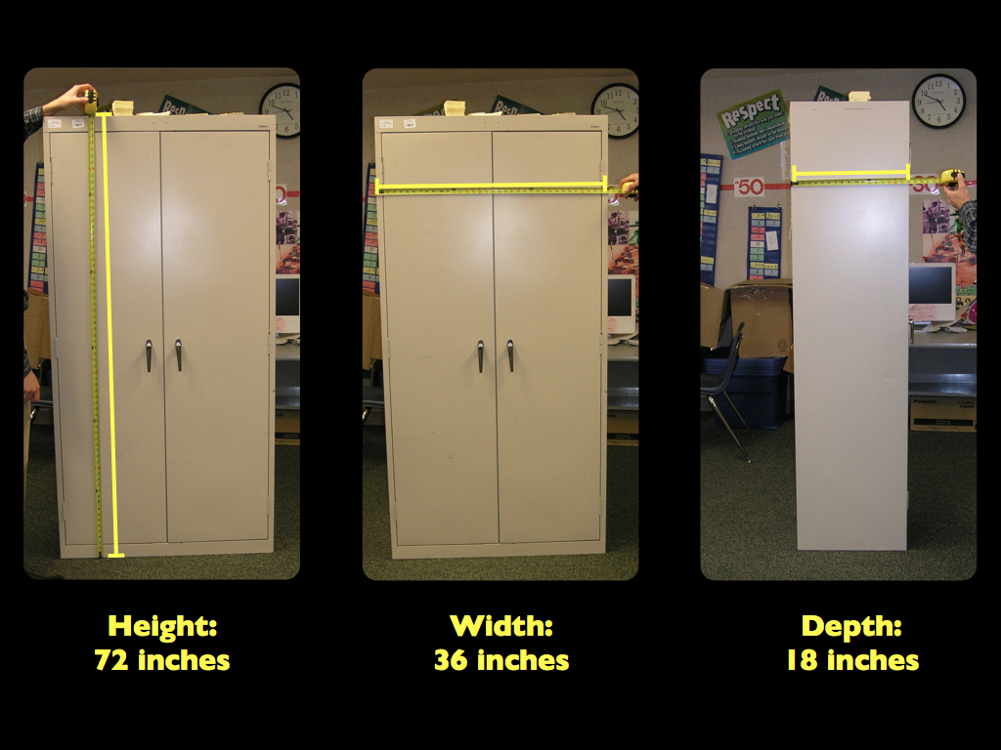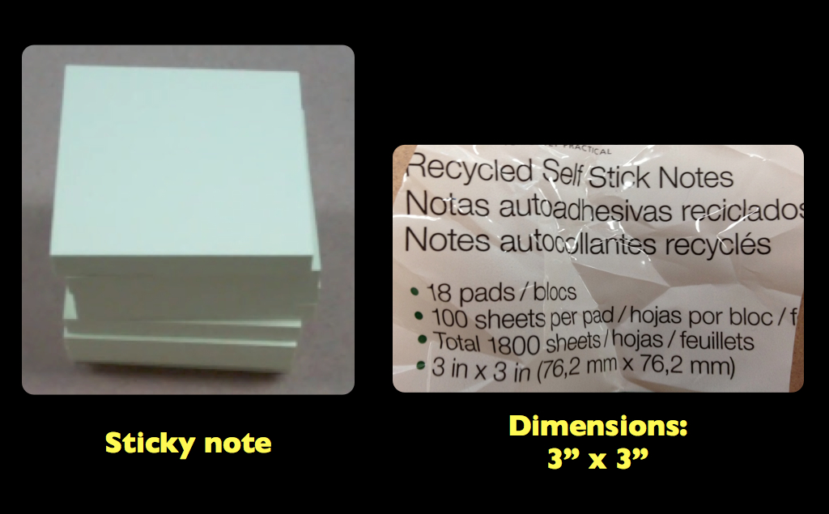
Check-in
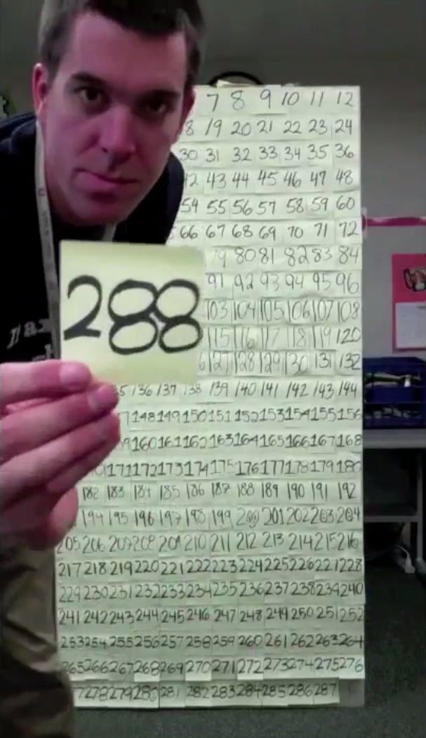
Sequels (for homefun)

You have 1,000,000 sticky notes.

Design a file cabinet that would be covered by all 1,000,000 sticky notes.

Find a rectangular prism in your house.
How many 3” by 3” Post-it notes would it take to cover it?

