Date: ______________
The Brain is Not Designed for Thinking
adapted from “Why Don’t Students Like School” by Daniel T. Willingham

Contrary to popular belief, the brain is not designed for thinking. Your brain serves many purposes and thinking is not the one it serves best. Your brain also supports the ability to see and to move, for example, and these functions operate much more efficiently and reliably than your ability to think. It’s no accident that most of your brain’s space is devoted to these activities. The extra brain power is needed because seeing is actually more difficult than playing chess or solving calculus problems.

You can appreciate the power of your visual system by comparing human abilities to those of computers. When it comes to math, science, and other traditional “thinking” tasks, machines beat people, no contest. Five dollars will get you a calculator that can perform simple calculations faster and more accurately than any human can. With fifty dollars you can buy chess software that can defeat more than 99 percent of the world’s population. But the most powerful computer on the planet can’t drive a truck. That’s because computers can’t see, especially not in complex ever-changing environments like the one you face every time you drive. Robots are similarly limited in how they move. Humans are excellent at configuring our bodies as needed for tasks, even if the configuration is unusual, such as when you twist your torso and contort your arms in order to dust behind books on a shelf. Robots are not very good at figuring out new ways to move, so they are mostly useful for repetitive work, such as spray painting car parts, for which the required movements are always the same. Tasks that you take for granted, for example, walking on a rocky shore where the footing is uncertain—are much more difficult than playing top level chess. No computer can do it.

Compared to your ability to see and move, thinking is slow, effortful and uncertain.

Thinking is slow.
Your visual system instantly takes in a complex scene. When you enter a friend’s backyard you don’t think to yourself, “Hmmm, there’s some green stuff. Probably grass, but it could be some other ground cover—and what’s that rough brown object sticking up there? A fence, perhaps? You take in the whole scene—lawn, fence, flowerbeds, gazebo—at a glance. Your thinking system does not instantly calculate the answer to a problem the way your visual system immediately takes in a visual scene.

Thinking is effortful. You don’t have to try to see, but thinking takes concentration. You can perform other tasks while you are seeing, but you can’t think about two things at the same time.

Thinking is uncertain. Your visual system seldom makes mistakes, and when it does you usually think you see something similar to what is actually out there—you’re close, if not exactly right. Your thinking system might not even get you close; your solution to a problem may be far from correct. In fact, your thinking system may not produce an answer at all, which is what often happens to people when they try to solve a new problem.

What actually happens when we think? A well-known cognitive psychologist, Daniel T. Willingham, defines thinking this way:
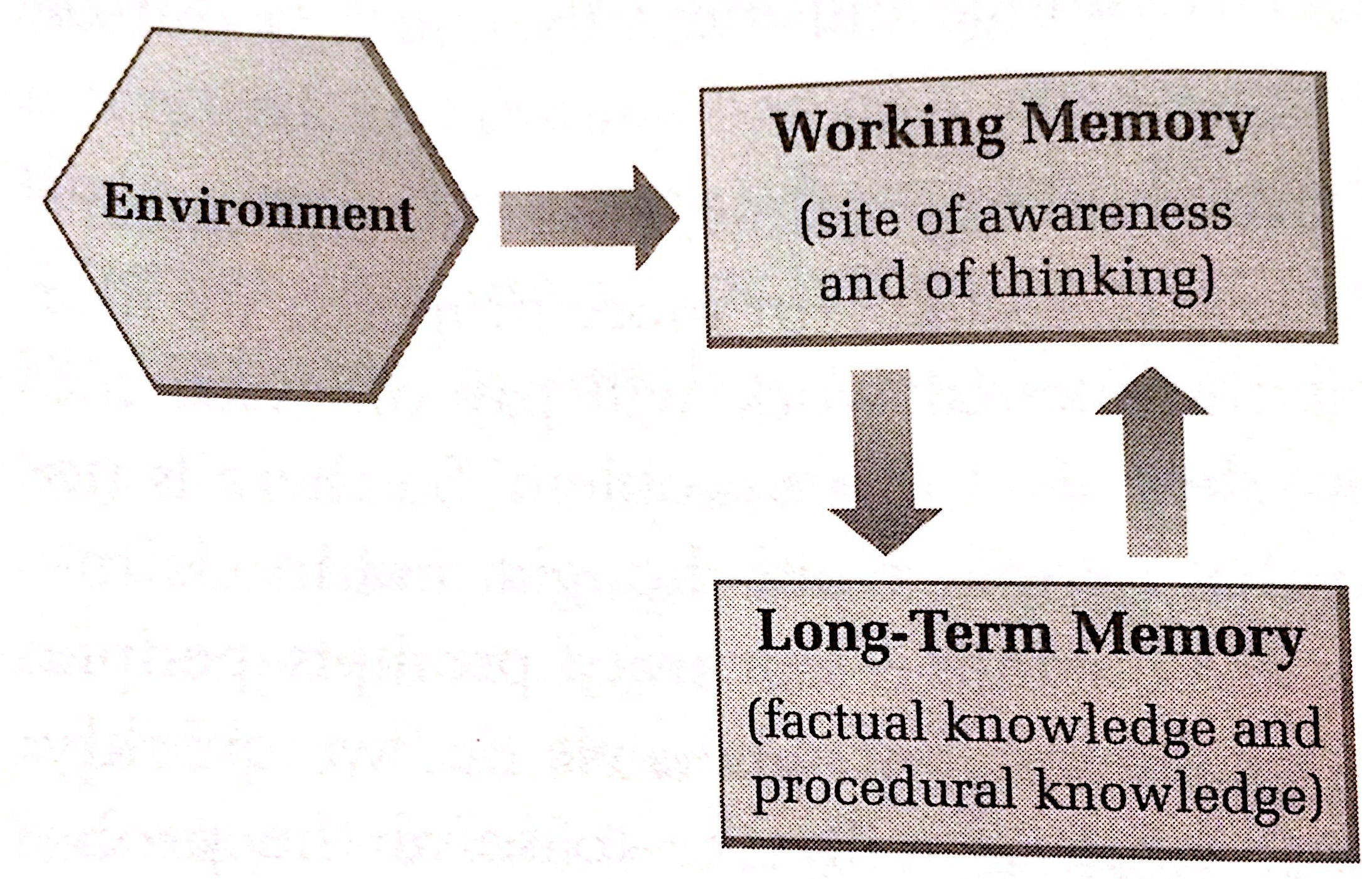
Thinking and new learning occurs when information from the environment and long-term memory are combined in new ways.

Take a look at the diagram on the right. You will see two terms that are very important to the thinking and learning process: long-term memory and working memory.

What is working memory?

For the moment, consider working memory to be the same as consciousness: it holds the stuff you’re thinking about. The arrow from the environment to working memory in the diagram shows that working memory is the part of your mind where you are aware of what is around you: the shaft of light falling onto a dusty table; the sound of a dog barking in the distance and so forth.

Working memory is all of the things that you are conscious of at any one moment. When it comes to learning, you can think of working memory as the active part of your memory system. “It’s like mental juggling,” says H. Lee Swanson, professor of Education at the University of California. “As new information comes in, you’re processing it at the same time as your store it, he says. “A child uses this skill when doing math calculations or listening to a story, for instance. She has to hold on to the numbers while working with them. Or, she needs to remember the sequence of events and also think of what the story is about.

What is long-term memory?

Of course, you can also remember things that are not currently in the environment. For instance, you can recall the sound of your mother’s voice, even when she’s not in the room. Long-term memory is the vast storehouse in which you maintain your factual knowledge of the world: that the Bronx is north of Manhattan; that your favorite flavor of ice cream is chocolate; that some numbers are even and some numbers are odd.

All of long-term memory resides outside your awareness. It lies quietly until it is needed, then enters working memory and so becomes conscious. For example, if I asked you, “What color is a polar bear?” you would say “white” almost immediately. That information was in long-term memory thirty seconds ago, but you weren’t aware of it until I posed the question that made it relevant to ongoing thought, whereupon it entered working memory.

If we look at Kate’s attempts to solve the handshake problem, we can see some of the features of thinking in action. We see that thinking is slow, effortful and uncertain. We also see how working memory and long-term memory are involved in Kate’s learning process.

The Handshake Problem

If there are 9 people in a room and every person shakes hands exactly once with each of the other people, how many handshakes will there be? Show how you got your answer.

Here is what Kate wrote about her process of working on this problem:

I have never liked math. My mother wasn’t very good at math either and she would always comfort me when I didn’t understand a problem by saying “Oh I was never any good at math either.”

I guess I got the idea that as a female it’s OK not to be good at math, which was a relief because I didn’t like it. I was always a good reader and writer and I loved learning so I didn’t worry about it very much. I can do simple addition, subtraction etc. but sometimes I made mistakes on my bank deposit slips so I always ask the teller to check my work.
I’m not confidence in math, though. I haven’t needed it since I got out of high school and I am not interested in solving problems if it’s just for the challenge. Last year, Mark T. and I had to go to a lot of meetings in Albany. It was a 3 hour drive each way so we had a lot of time to talk about teaching and learning. Mark talked to me about my fear of math. I said it wasn’t that I was afraid of math, I just didn’t like it.

On one drive, though, I finally became convinced that maybe he was right. I had decided that I was not a math person because I did not want to do the work of changing that. Mark kind of tricked me into learning some math, because I really didn’t want to. But we were writing lessons together. The curriculum was about how people learn. It made logical sense for me to study my own learning and since math is my weakest subject, it was where I had the most to learn.

The Handshake Problem
The first problem Mark gave me was the handshake problem. He said he wanted to see me do it to help him figure out how to write the lesson. Very sneaky.

Problem-solving Process
At first I thought,” OK nine people shaking every other person in the room. 9x9 = 81.
“Tell me how you got that,” said Mark. I explained but I said I wasn’t sure so Mark encouraged me to draw it.

When I drew it I suddenly realized that I wouldn’t shake my own hand, so really it would be 9x8. Nine people shaking hands with everyone in the room except him/herself. Again Mark asked “Are you sure? How do you know?” With his encouragement, I drew it again. I drew circles to represent each person and dots around the circles to represent each person that the “circle” was shaking hands with. This helped me be sure. I looked back at the problem—it was asking me how many handshakes there were—so I felt more confident about my answer.

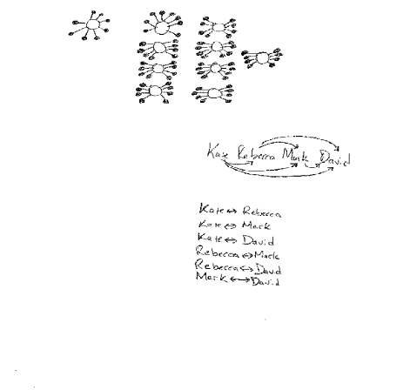

Then Mark said “Let’s try it with smaller numbers. How many handshakes would it be if it was 4 people?

I said “Twelve. Four people in a room, shaking hands with 3 other people = 12 handshakes”.

Mark said “Are you sure?”

“I think so,” I said.

Mark said “Let’s act it out.” So we acted out the problem with two of our co-workers, David and Rebecca.

There were now four of us in the room -- me, Mark, Rebecca and David. I read the problem out loud so everyone could hear it. I shook hands with Mark, Rebecca and David, and recorded how many handshakes (3). Then Mark started shaking hands, but when we went to shake my hand Rebecca said “Mark already shook Kate’s hand. According to the problem, each person only shakes hands with each other person exactly once.”

That was very confusing and we talked about it and I reread the problem a couple of times. Somehow I just couldn’t wrap my mind around it.

So then we acted the whole thing out and I counted the shakes, with no one shaking hands more than once with another person.

It ended up like this:
Kate shakes hands with Rebecca, David and Mark = 3 handshakes
Mark shakes hands with Rebecca and David = 2 handshakes
Rebecca shakes hands with David =1 handshake
At this point David has shaken hands with each person so he is a 0.
So the total number of handshakes = 6.

But I still didn’t feel that sure about it, so Mark and I diagrammed it.

And then it finally “clicked” for me, rereading the problem again.

Kate’s struggles with the Handshake Problem illustrate why thinking is so hard. Learning new things is hard because our brains must do 2 or 3 things at once. We must keep new information in mind while also drawing upon long-term memory and new information from the environment to come up with a solution.

Limits of Working Memory.
Scientists have long known about the limits of working memory. The limits of working memory are also something that each of us experiences every day. Anyone who has tried to talk on a cell phone while driving or answer a child’s questions while performing household tasks knows how difficult it is to do two things well at the same time.

Scientists have done studies to learn more about the limits of working memory. Some studies suggest that the amount of information an adult can hold in working memory is about three to five chunks of information.

If the limits of working memory make thinking so difficult, what can we do?

Kate’s work with the Handshake Problem illustrates the way we sometimes use strategies to help us overcome the limits of working memory. Kate was able to compensate for these limits in several ways:

Drawing the problem.
By drawing the problem, Kate was able to take some of the load off of her working memory. Drawing the people and the handshakes was a way to “store” this information without having to remember it. This freed up space in her working memory to think about the problem as a whole.

Using smaller numbers.
Using smaller numbers was another way to take some of the load off of Kate’s working memory. By using smaller numbers, she did not have to devote as much mental energy to the calculations she was doing. It was easier to multiply and add the numbers and to draw them out. Again, smaller numbers allowed Kate to “free up” some of her mental resources and devote this energy to thinking about different ways she could solve the problem.

Acting it Out.
Acting it out was yet another strategy that allowed Kate to solve the problem. By actually acting it out, Kate was able to see the situation in a way that was difficult when she was just imagining it in her head. Seeing the actual handshakes allowed her the opportunity to be confused about who was shaking whose hand. That confusion allowed her to understand an important part of the problem.

