Look at the figures below.
Figure 1 Figure 2 Figure 3

Complete the following sentence:

As the figure number changes, ____________________________________________ also changes.

Figure 1 Figure 2 Figure 3

- Draw the next two figures.

Figure 4:

Figure 5:

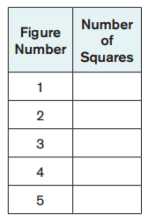
- Complete the table to the right.

- In a few sentences, describe what the tenth figure would look like.

- Explain how you would figure out the number of squares in the 99th figure.

- BONUS QUESTION: In a few sentences, describe how you would determine how many squares there are in any figure in the pattern.

