**What do you need to know about the TI-30XS calculator?**

The math section of the TASC is divided into two sections. You can use a calculator for the first section, but not for the second section. Even on the section where the calculator is allowed, you won’t need it for many of the questions. In fact, more than half of the problems on the whole math section do not require any calculations at all! 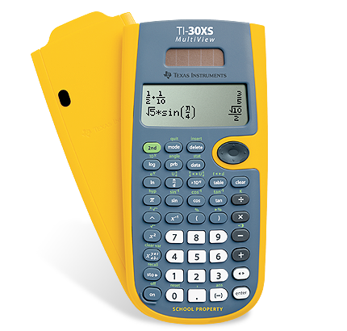

However, it is important that you are comfortable with the calculator so that it can be used as a support in the calculator-allowed section of the test.

**Some things test takers should know about the calculator:**

|  |  |  |
| --- | --- | --- |
| * Use  instead of **=**. * To erase screen*:* * Use the arrow keys to move the cursor. This includes moving up to previous calculations: * Basic arithmetic operations (multiplication, division, addition, subtraction). * The difference between the *negative number* key and the *subtraction* key.   + Negative sign:   + Subtraction: * Convert from fraction to decimal: | | |
| Practice: | | |
| 1. What fraction is equivalent to 0.875? 2. What is -344 divided by 4? | 1. What is -24 times 3? 2. Which is smaller, or 0.875? | 1. What is the difference between the coldest temperature you’ve ever experienced and the hottest temperature you’ve experienced? |
| **Exponents**   * + Taking a number to the 2nd power (squaring) can be done with the *x2* key. First press the number you want to square and then press .   For example:  To find 132, you would press 13 and then   * + To raise numbers to other exponents (higher than the second power), first press the base number, then  and then the exponent.   For example:  To find 26, press 2, then , then 6. | | |
| Practice:   1. 172 = 2. 74 = 3. Which is bigger, 23 or 32? 4. Put these in size order: 26 43 82 5. Which is greater, 65 or 56? | | |
| You will notice that some buttons have words or symbols above them in green. You can use these functions by pressing the  button.  For example, to turn off calculator: Press , and then | | |
| **Roots**   * + Square roots: , , the number you want to find the square root of.   + Cube roots: , ,   For example:  To find the square root of 144: , , 144  To find the cube root of 216: , , , 216  **Note**: The TASC is limited to square roots (“to the 2nd power”) and cube roots (“to the 3rd power”). | | |
| Practice:   1. What is the square root of 961? 2. What number times itself equals 784? 3. What is the cube root of 1728?   Decide if each of the next three statements is True or False.  If False, rewrite the statement so that it is true:   1. The square root of 16 is 256. 2. The cube root of 9 is 3. 3. The cube root of 343 is larger than the square root of 49. | | |
| **Useful, but not necessary:**   * Creating in-out tables from functions (*y = 2x + 1*, for example):  , , , , , , , , , * To enter a fraction into the calculator, press , then the numerator, then the down arrow , then the denominator, then the right arrow .   Don’t worry too much about this. It is better to focus on understanding fractions, rather than how to calculate them with this particular calculator.   * Holding on and hitting clear will empty memory: , * Convert number to percent: , * Scientific notation: | | |
| **Some things you do not need to know for the test:**   * Logarithms * Trigonometry (sin, cos, tan) * Pretty much all of the other buttons. | | |
| **Additional Resources:**   * TASC test page on TI-30XS:   http://www.tasctest.com/tasc-test-calculators-for-test-takers.html | | |

