Kareem’s Paystub
Kareem works as a checkout clerk at Best Food Supermarket and received the following report.

Employee Name | Kareem Martin
Employee ID | #32156
Pay Period Ending | Hours | Net Pay
Dec 11, 2016 | 20 | $325.00
Dec 4, 2016 | 26 | $430.00
Nov 27, 2016 | 32 | $535.00
Nov 20, 2016 | 22 | $360.00
Nov 13, 2016 | 24 | $395.00
Nov 6, 2016 | 30 | $500.00

What do you notice?
What do you wonder?

Calculating Net Pay
Kareem is looking over his recent paychecks to make sure he got paid correctly.

Employee Name | Kareem Martin
Employee ID | #32156
Pay Period Ending | Hours | Net Pay
Dec 11, 2016 | 20 | $325.00
Dec 4, 2016 | 26 | $430.00
Nov 27, 2016 | 32 | $535.00
Nov 20, 2016 | 22 | $360.00
Nov 13, 2016 | 24 | $395.00
Nov 6, 2016 | 30 | $500.00

How is Kareem’s net pay being calculated? Explain your thinking below.

Support and Push
Cut out these cards before class. Share a card with a group of students only if they need it to keep working productively.
SUPPORT
How much money would Kareem make if he worked 28 hours? | Hours Net Pay  20 $325.00  22 $360.00  24 $395.00  26  28  30
If Kareem worked 16 hours, how much would he get paid? | If Kareem worked 23 hours, how much would he get paid?

PUSH
How much money would Kareem get in net pay if he worked just 2 hours in a week? | How much is being deducted from Kareem’s salary each week?
For the week of October 30th, Kareem was paid $587.50.  How many hours did he work? | Write a function to calculate Kareem’s net pay from the number of hours he works.

Write Questions to Match the Calculations
The numbers below are from Kareem’s paystub. Each of these calculations can be used to answer different questions.
What questions do each of these calculations answer?

- 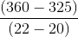
- 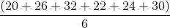
- 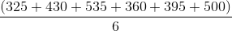
- 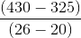

Graphing Work Hours and Net Pay
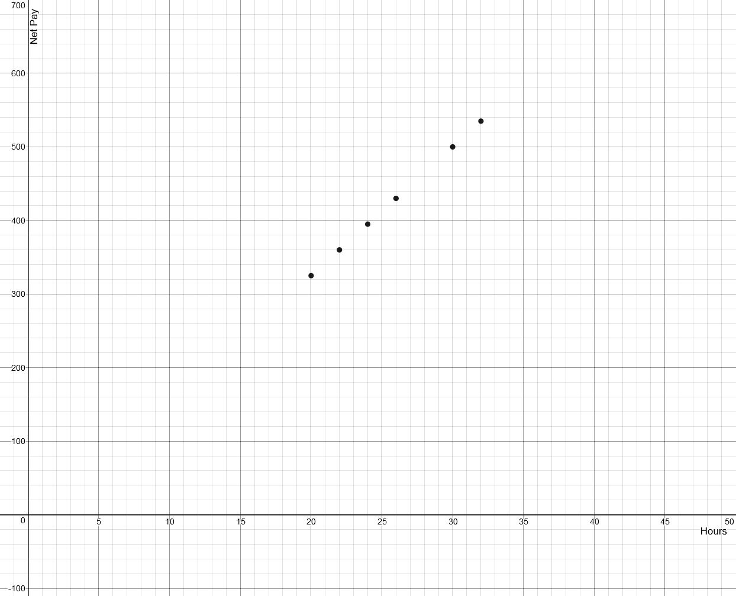

Complete the table below and then plot all data on the graph above.
Hours | 18 | 20 | 22 | 24 | 26 | 28 | 30 | 32 | 34 | 36 | 38 | 40
Net Pay |  | 325 | 360 |  | 430 |  | 500 | 535

TASC Practice Question
Kareem works a part-time job at a supermarket in his neighborhood. He is paid an hourly wage and has a weekly deduction from his paycheck that goes towards his transportation. The number of hours and the pay he received for the past 6 weeks are shown in the table.

Hours | Pay ($)
20 | 325
26 | 430
32 | 535
22 | 360
24 | 395
30 | 500
Which linear function models the relationship between the number of hours worked, t, and his total pay, P(t)?

- P(t) = 17.5t
- P(t) = 16.25t
- P(t) = 25t - 17.5
- P(t) = 17.5t - 25

Why did you choose this answer?

