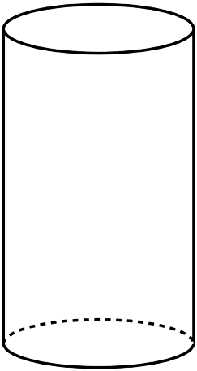**Write down everything you can about this figure.**

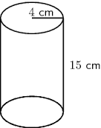 **Write down everything you can about this figure.**