The Handshake Problem
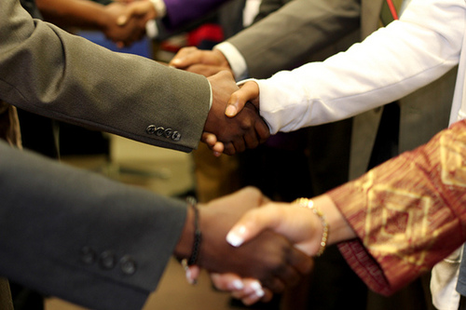
If there are 9 people in a room and every person shakes hands exactly once with all of the other people, how many handshakes will there be?
Show how you got your answer.

